ARMAMENTARIUM

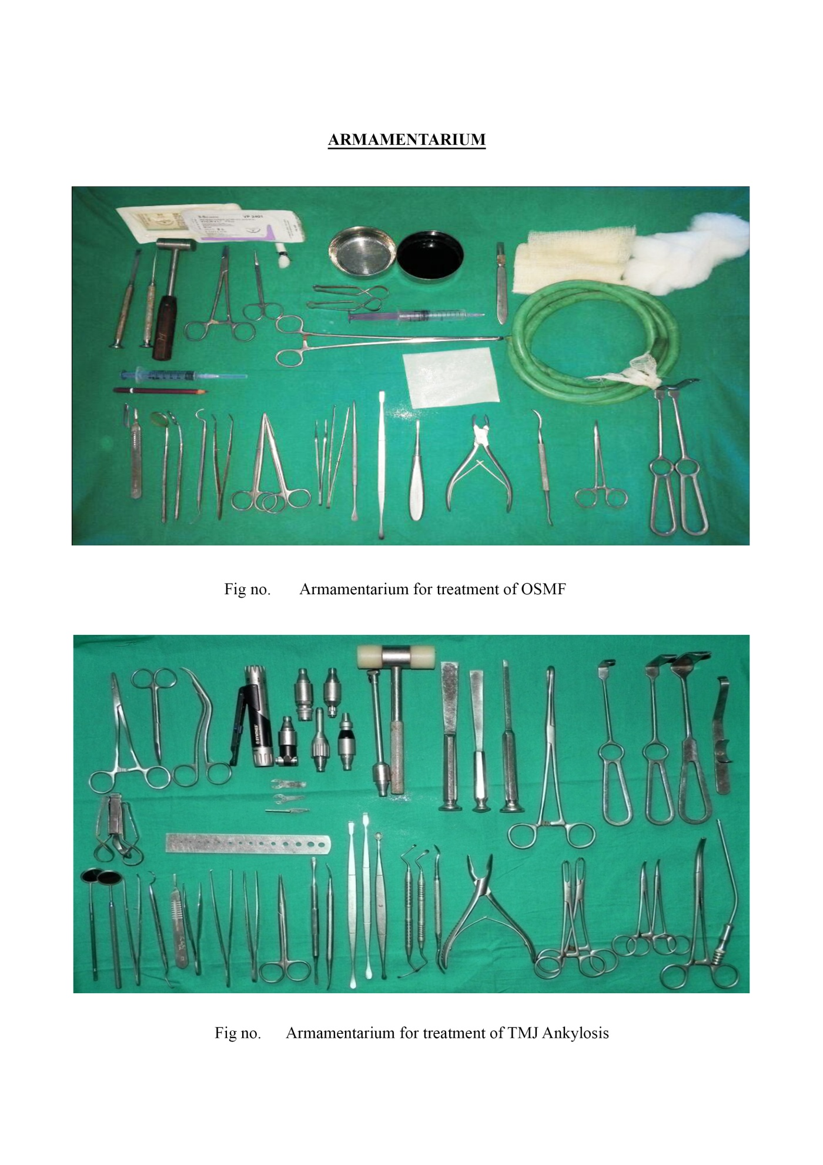
Fig No. 3.2 Armamentarium For Treatment of OSMF

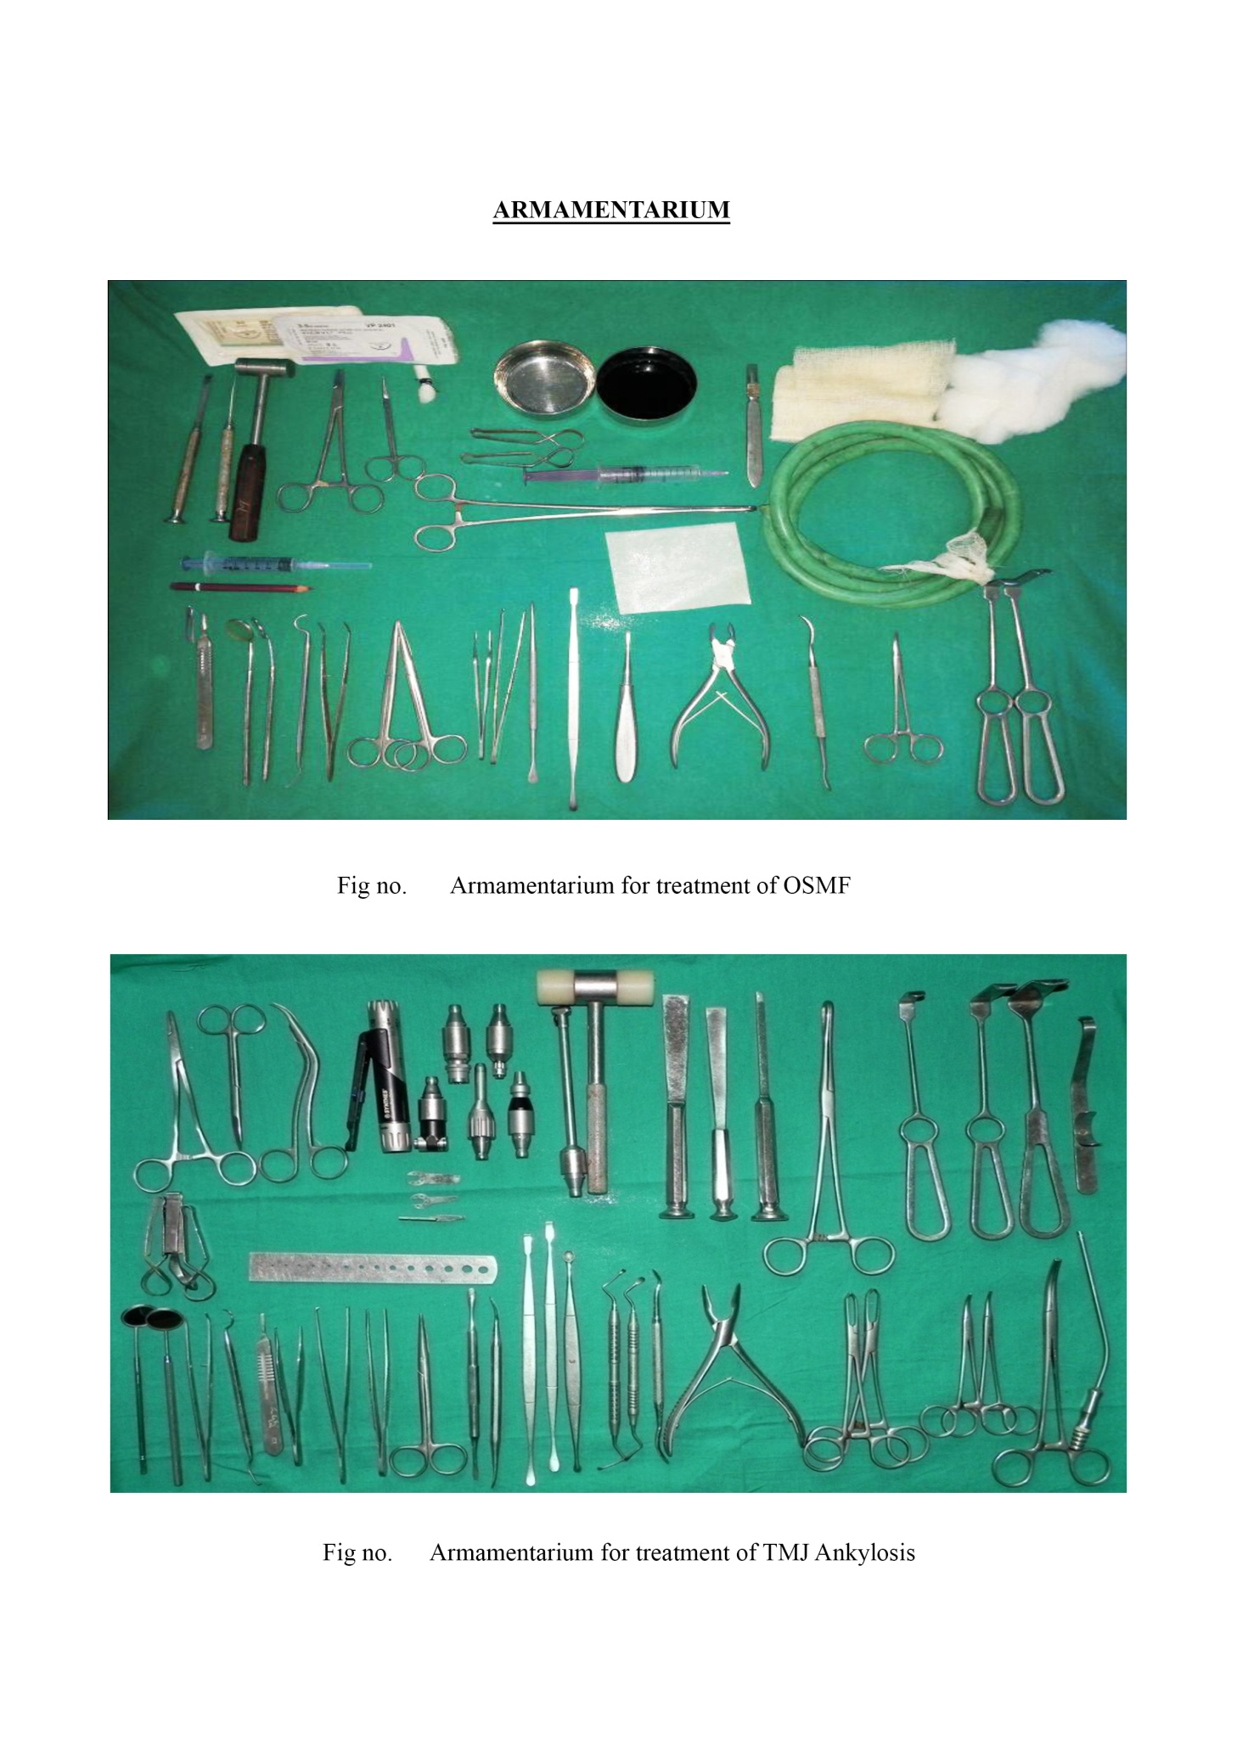
Fig No. 3.3 Armamentarium For Treatment of TMJ Ankylosis

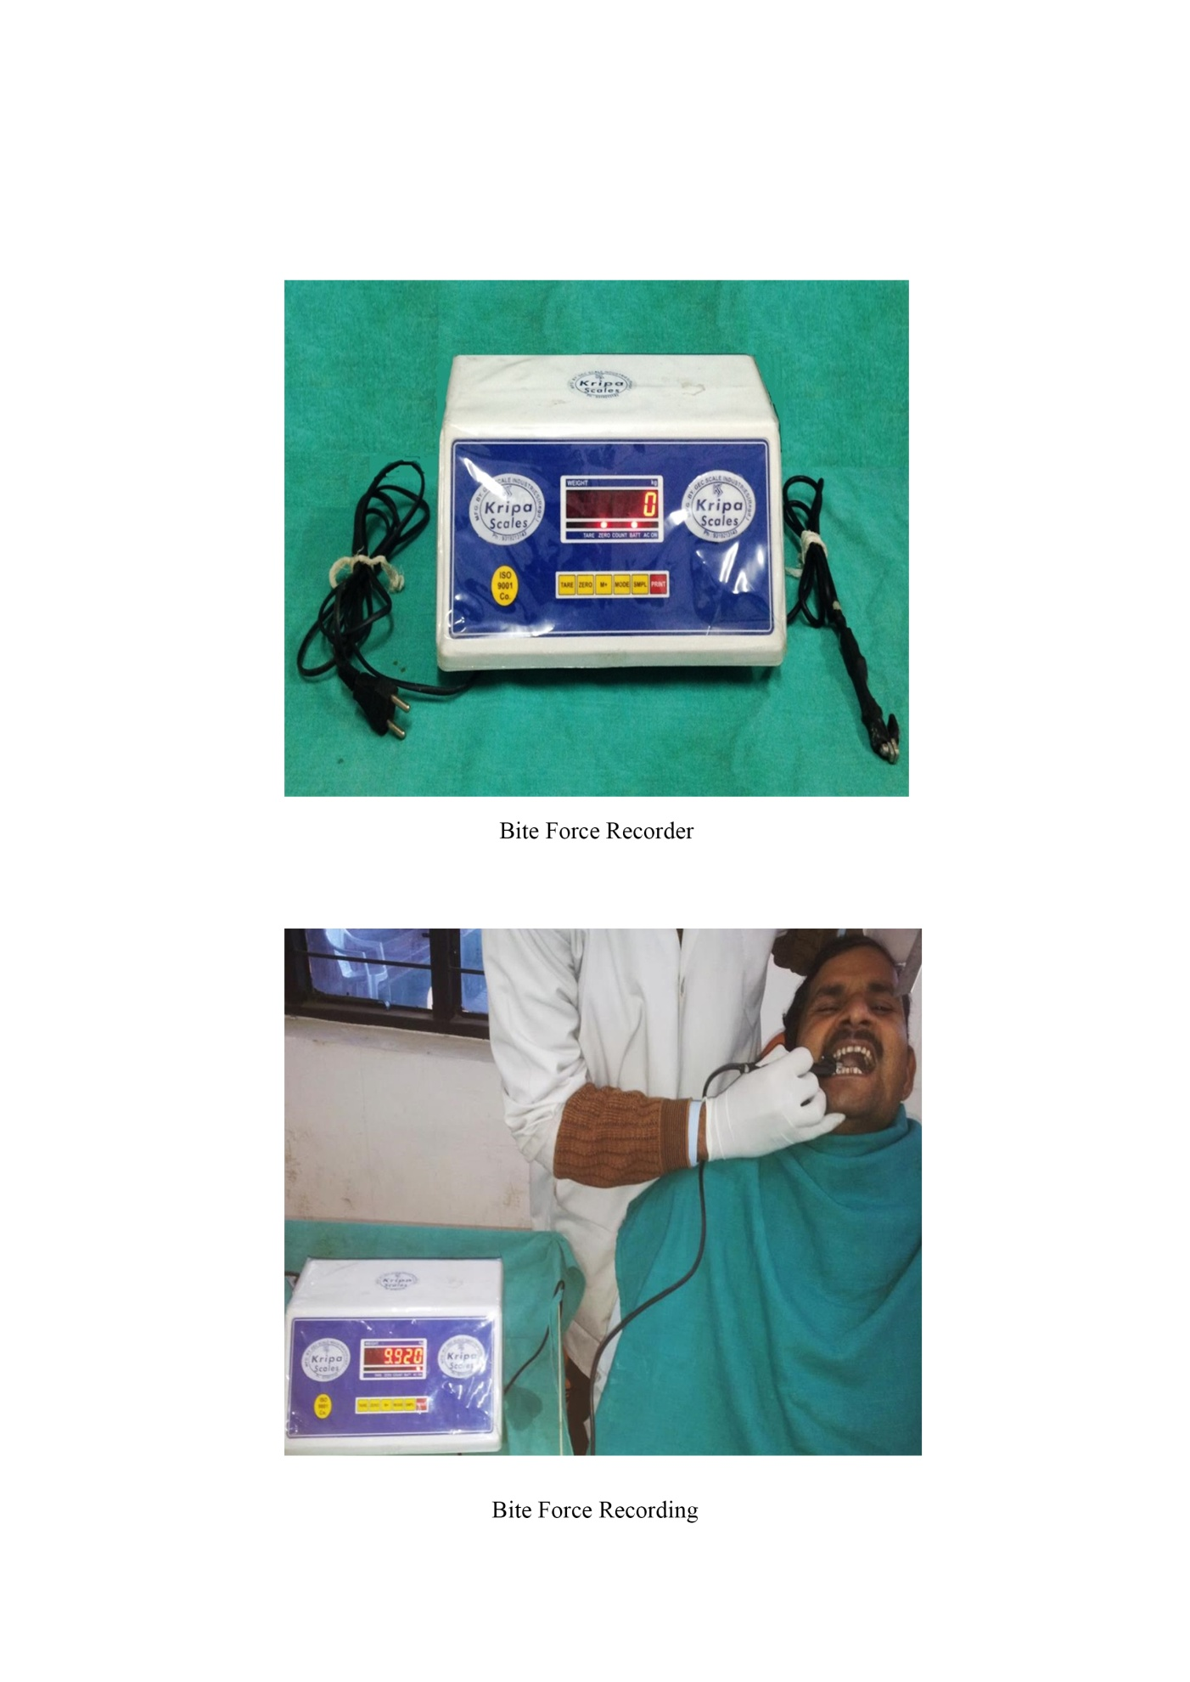
Fig No. 3.4 Bite force recorder

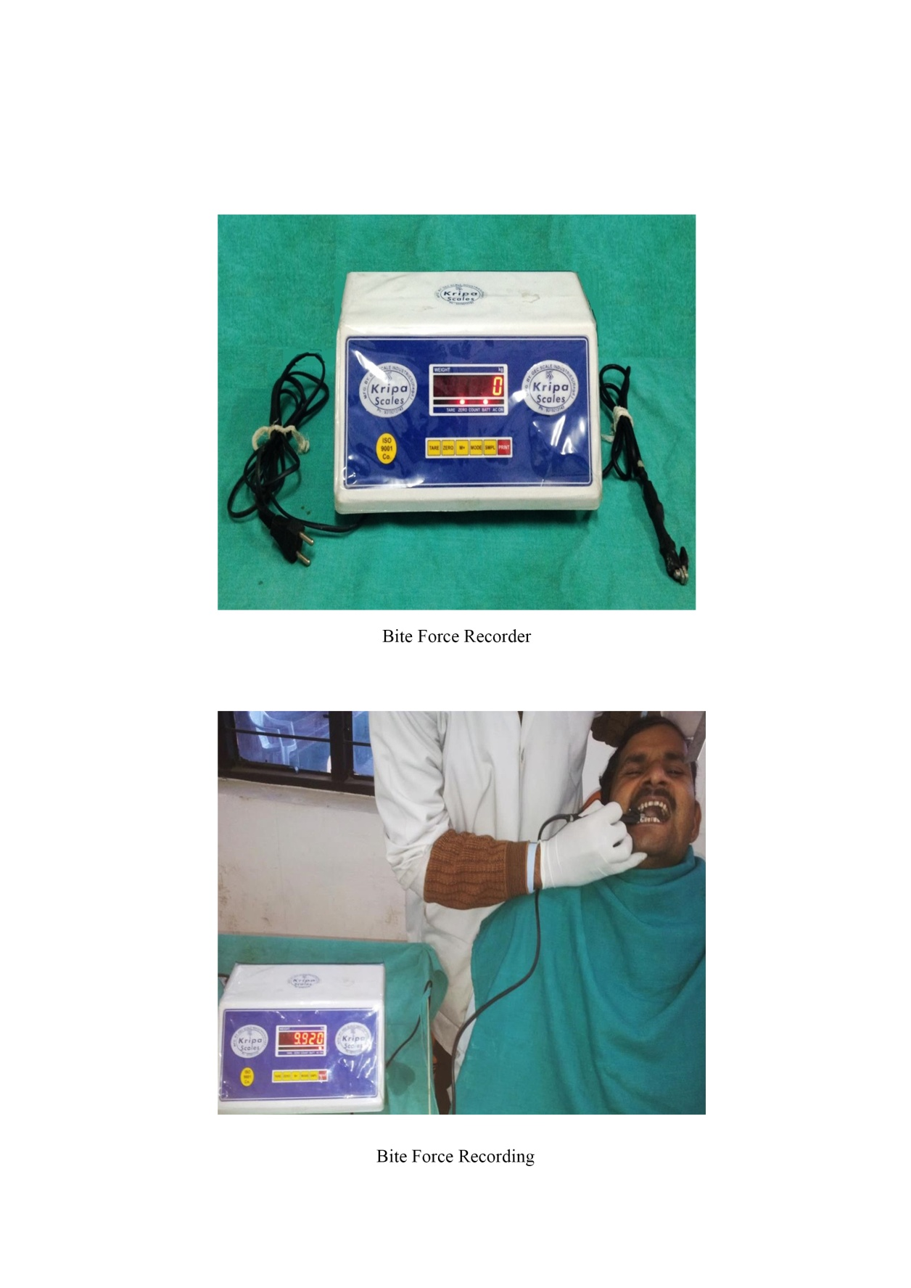
Fig No. 3.5 Bite force recording

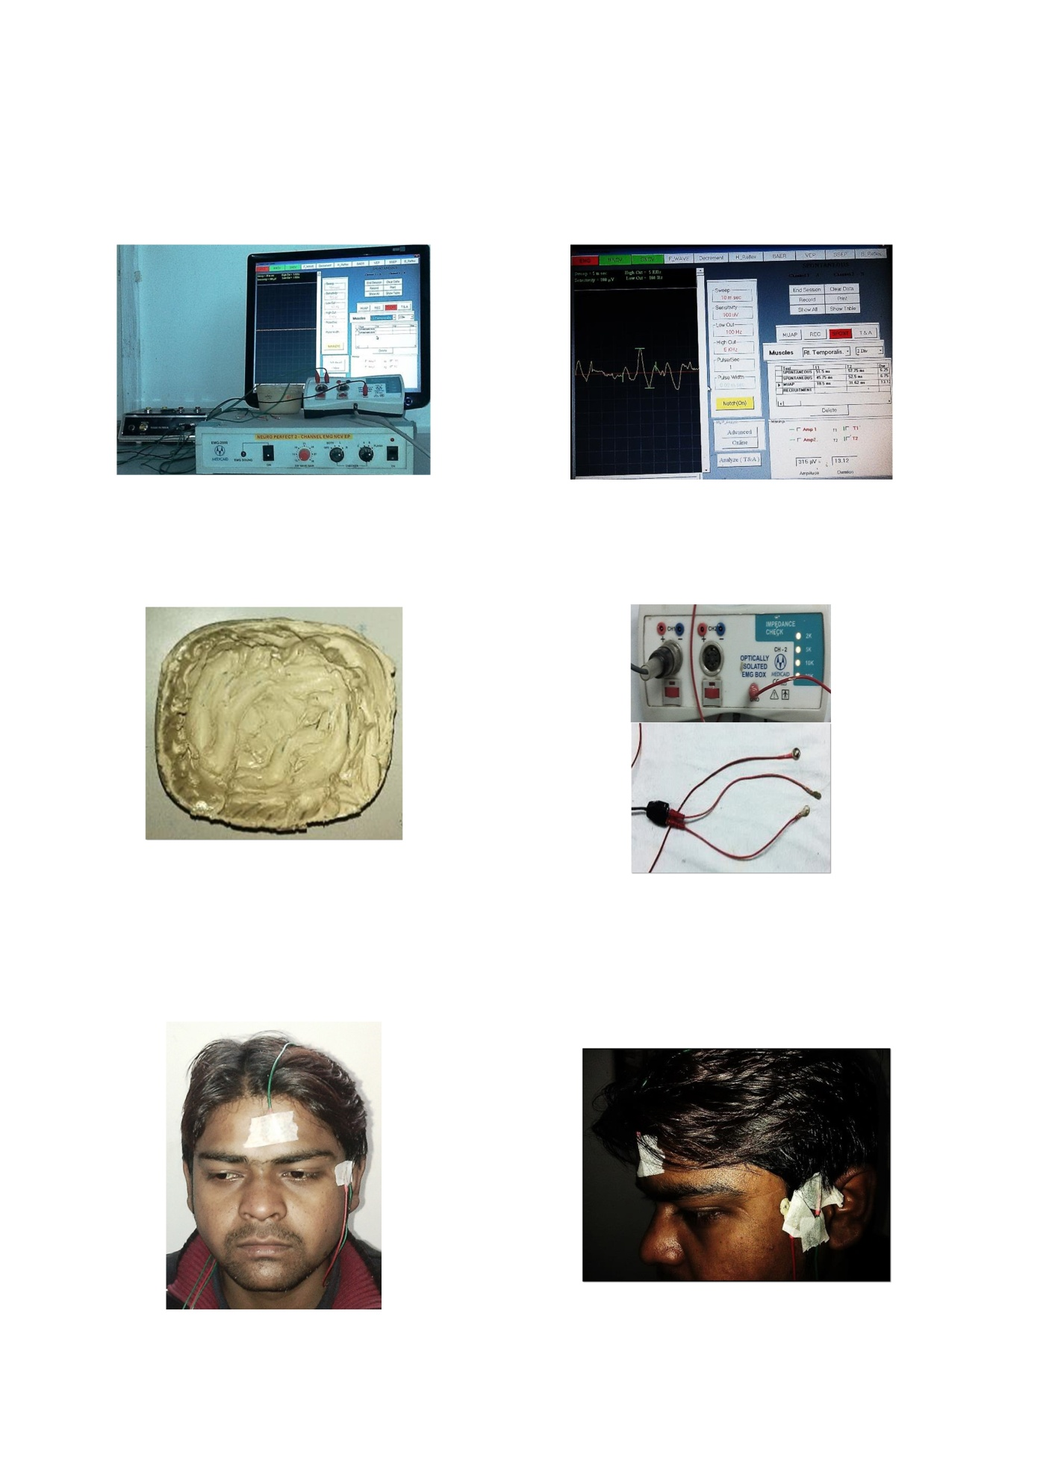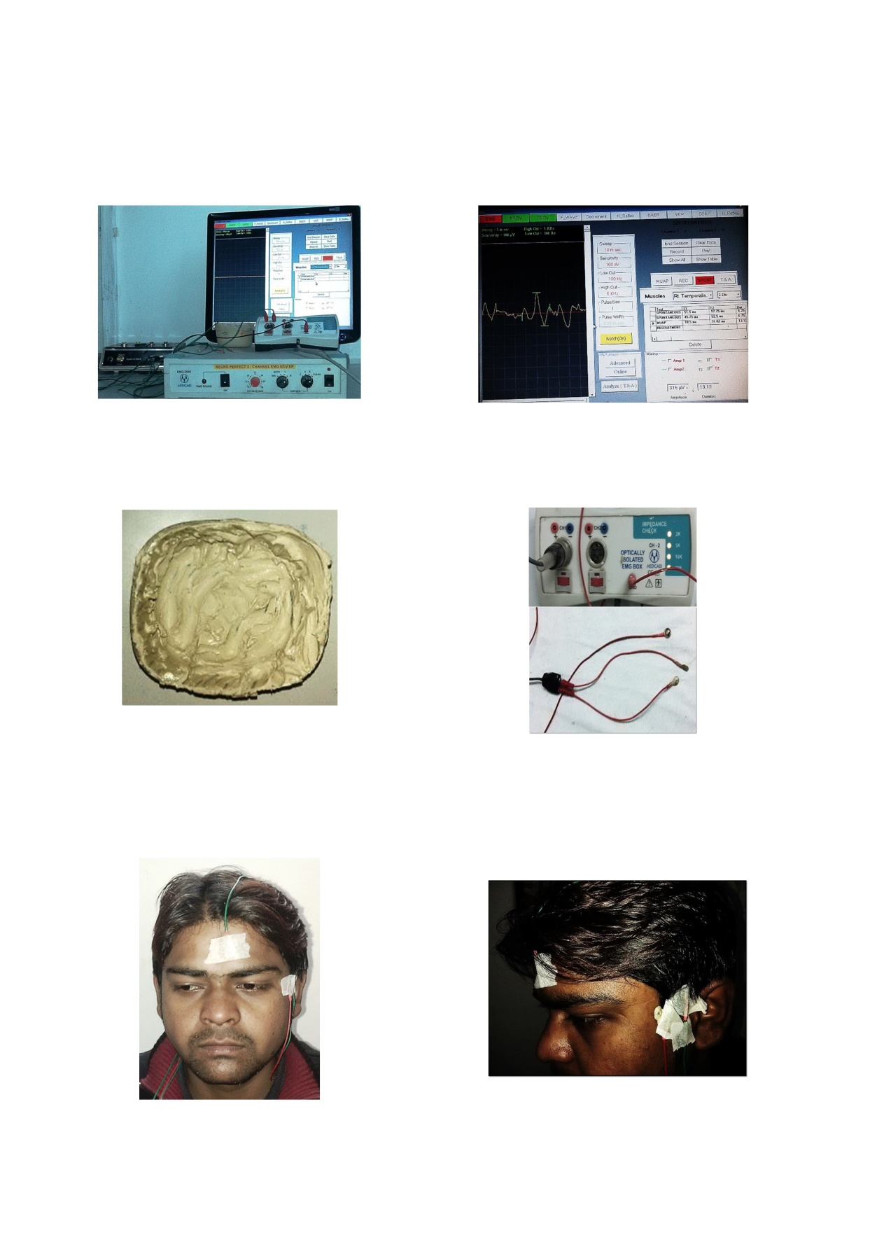
Fig No. 3.6 EMG Equipment Fig No. 3.7 EMG Moniter

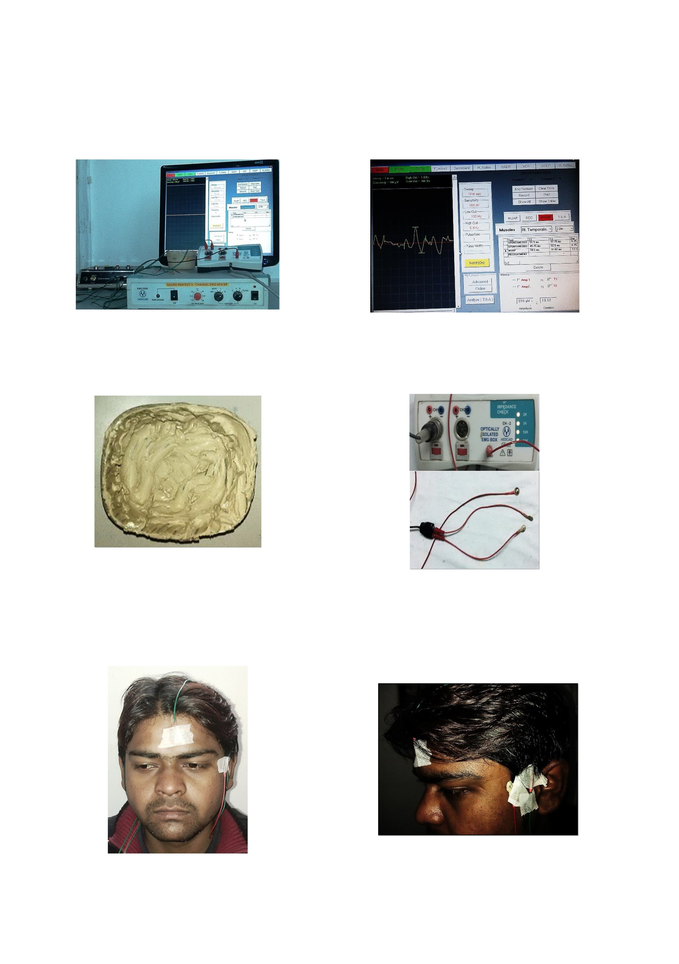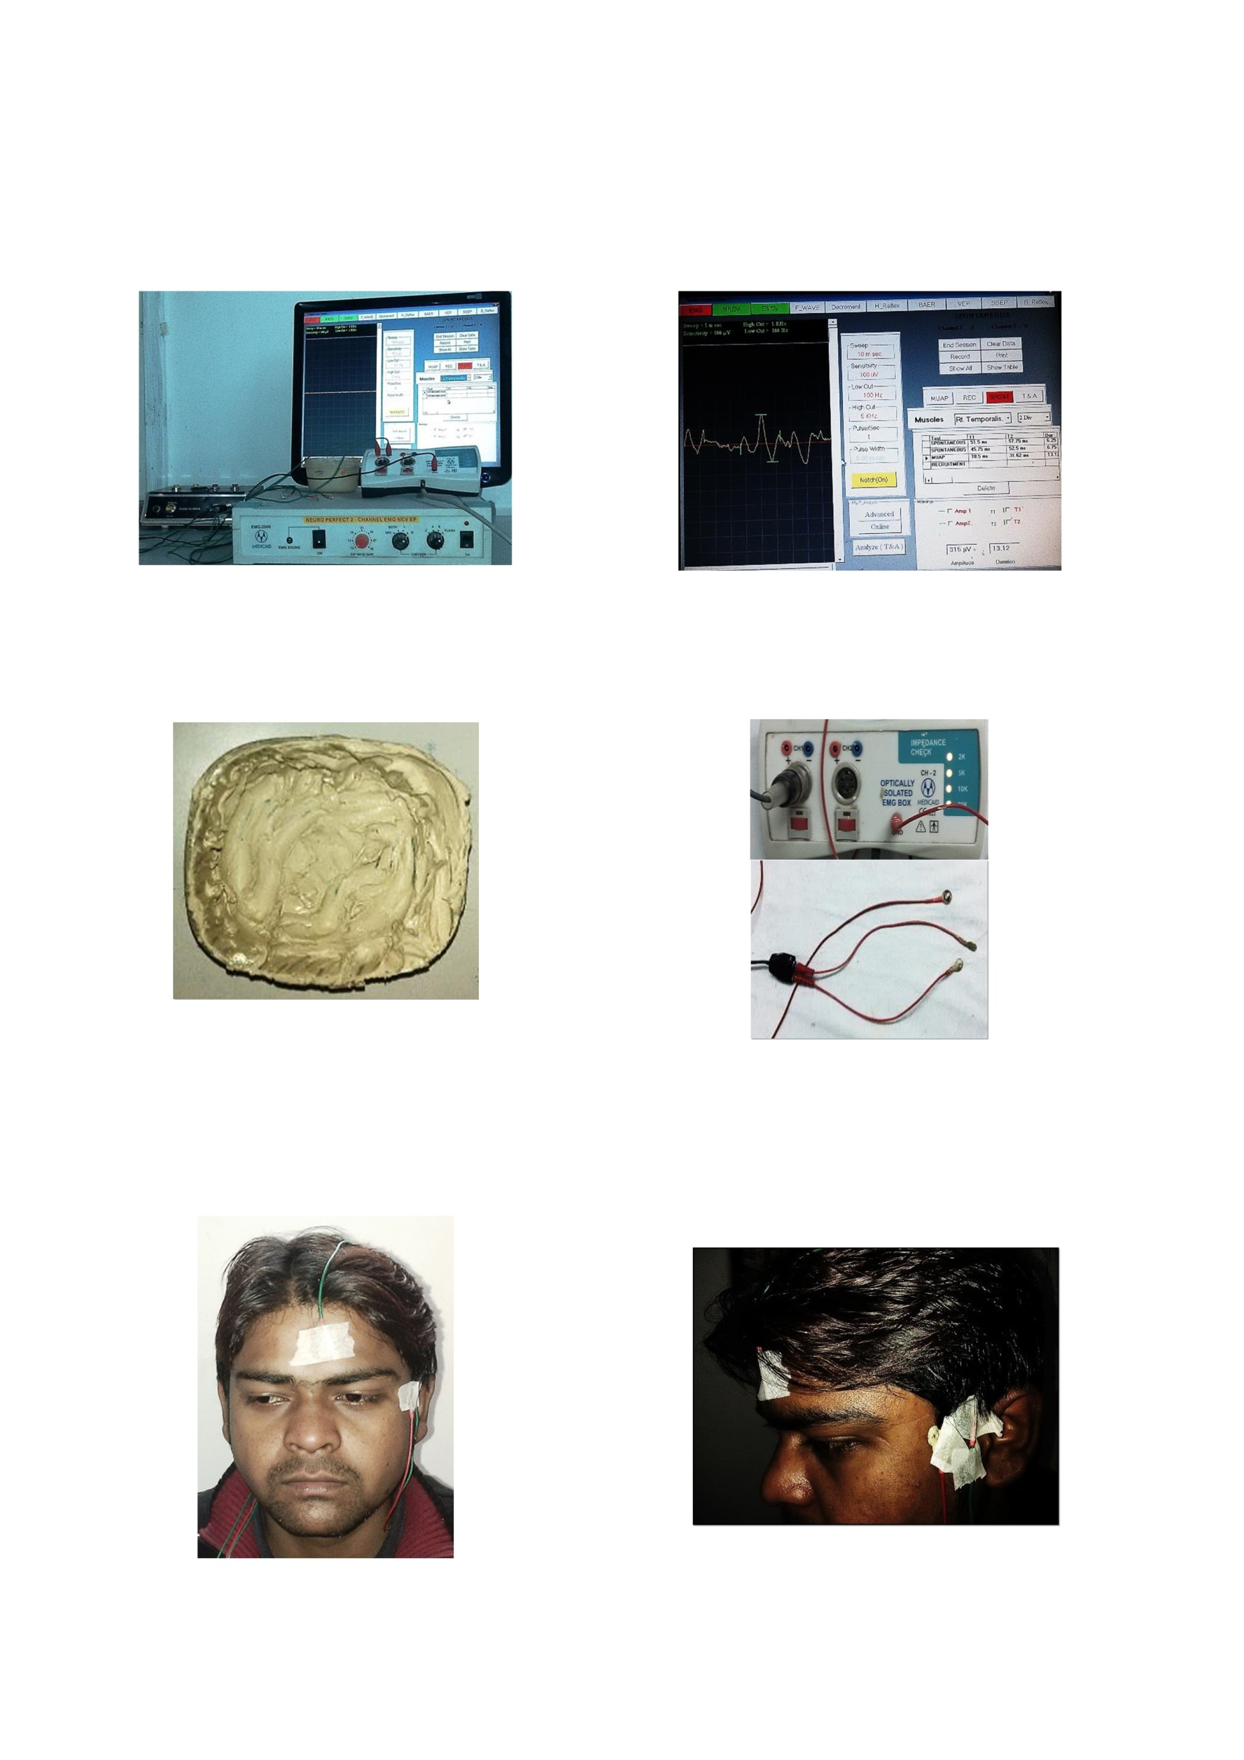
Fig No. 3.8 Voltage Controller & Fig No. 3.9 EMG Recording
EMG Electrodes
CASE 1
PRE-OPERATIVE PHOTOGRAPHS
OSMF (Without Coronoidectomy)

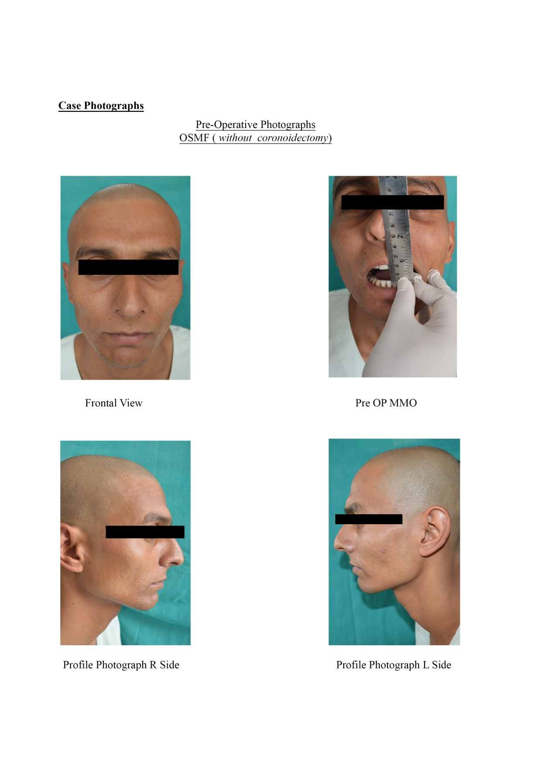
Fig No. 3.10 Frontol View Fig No. 3.11 Pre-Operative MMO

Fig No. 3.12 Profile Photographs R Side Fig No. 3.13 Profile Photographs
L Side

INTRA-OPERATIVE PHOTOGRAPHS

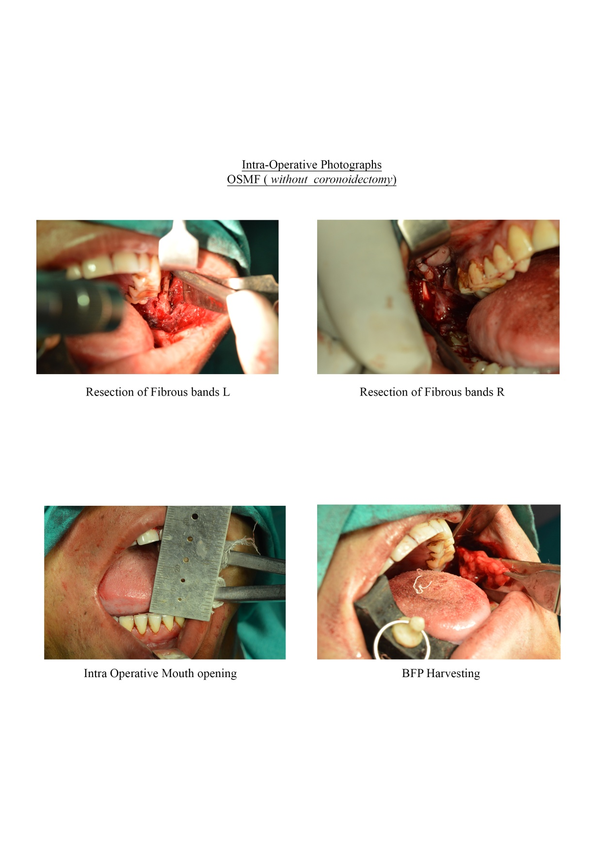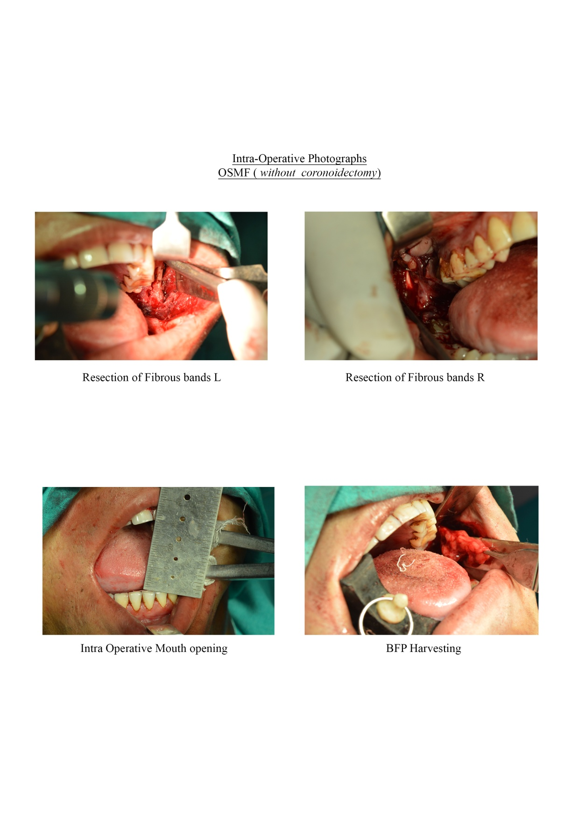
Fig No. 3.14 Resection of Fibrous Fig No. 3.15 Resection of Fibrous
Bands L Side Bands R Side

Fig No. 3.16 Intro Operative Mouth Fig No. 3.17 BFP Harvesting
Opening

FOLLOW UP

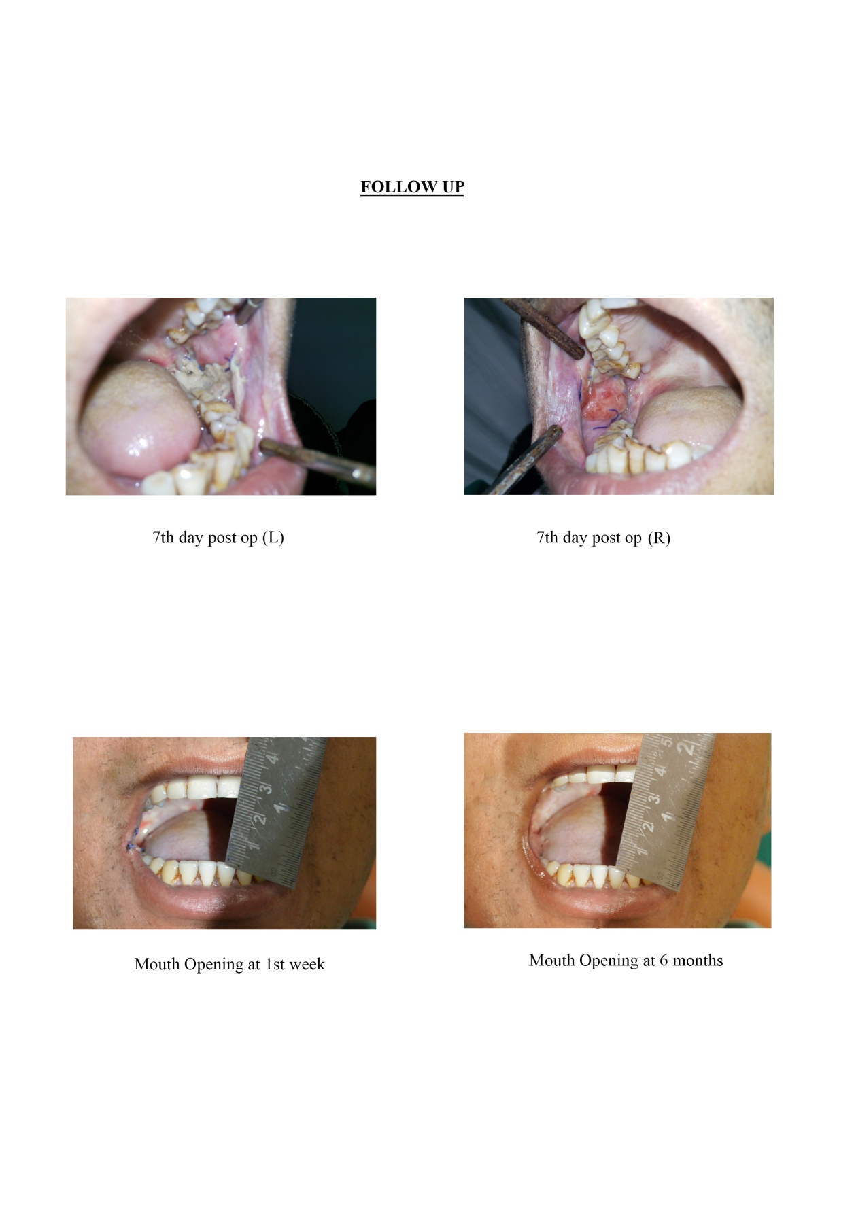
Fig No. 3.18 7th Day Post Operative Fig No. 3.19 7th Day Post Operative L Side R Side

Fig No. 3.20 Mouth Opening at Fig No. 3.21 Mouth Opening at
1 Weak 6th Month

CASE 2
PRE-OPERATIVE PHOTOGRAPHS
OSMF (With Coronoidectomy)

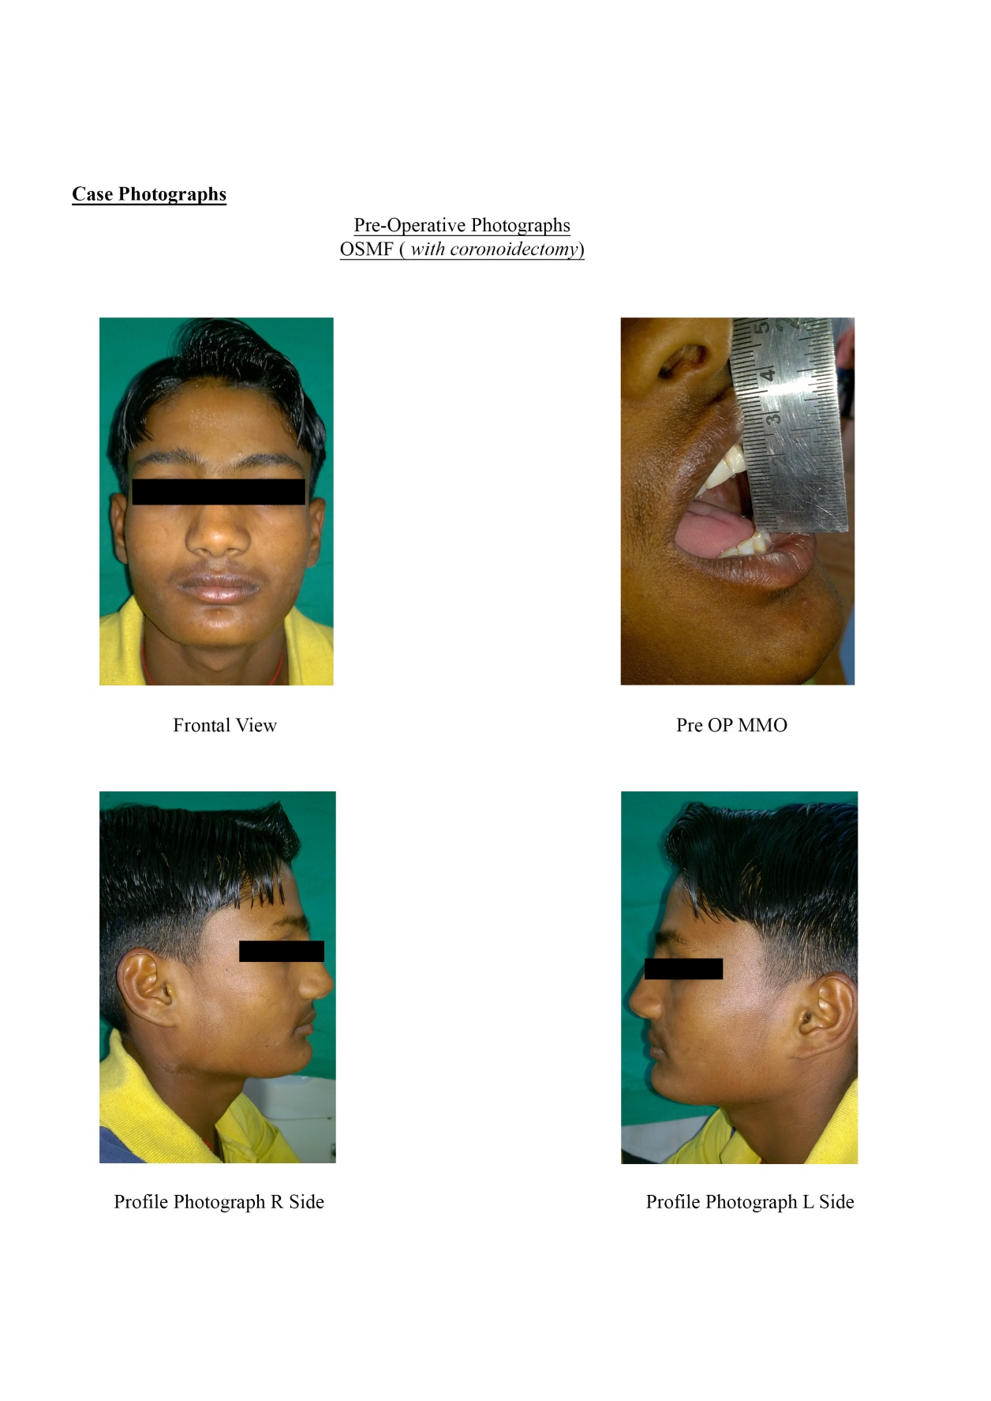
Fig No. 3.22 Frontol View Fig No. 3.23 Pre-Operative MMO

Fig No. 3.24 Profile Photographs Fig No. 3.25 Profile Photographs
R Side L Side

INTRA-OPERATIVE PHOTOGRAPHS
OSMF (With Coronoidectomy)

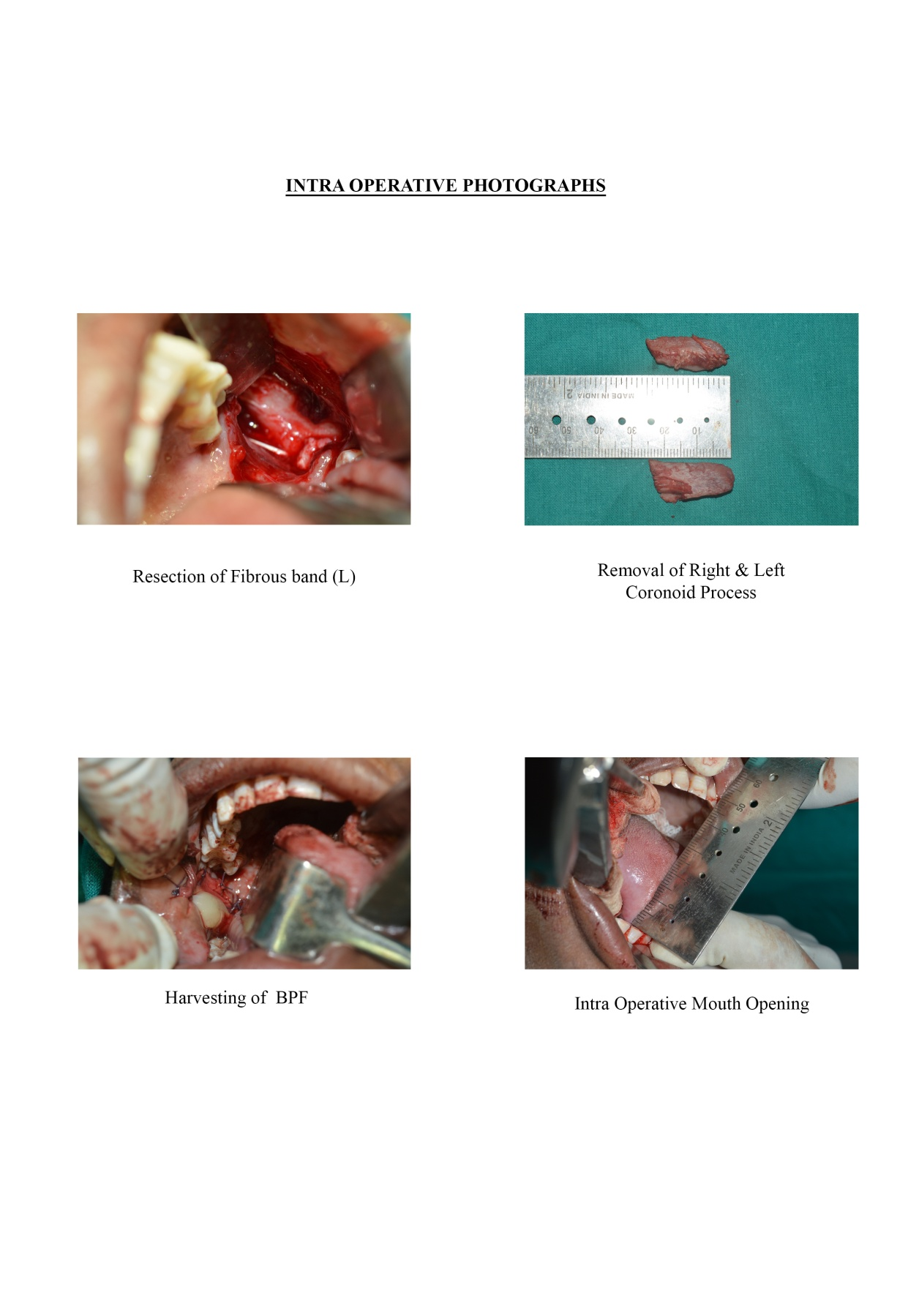
Fig No. 3.26 Exposure of Coronoid Fig No. 3.27 Removal of R & L
Process Coronoid Process

Fig No. 3.28 BFP Harvesting Fig No. 3.29 Intra-Operative
Mouth Opening

FOLLOW UP

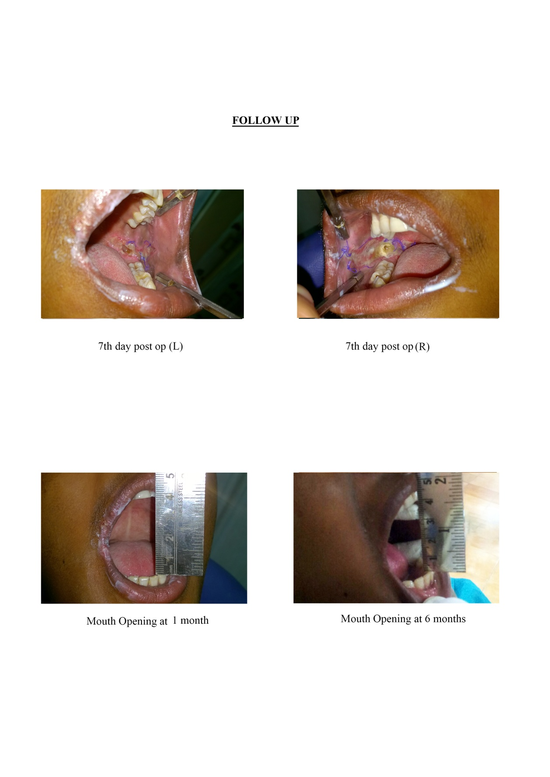
Fig No. 3.30 7th Day Post Operative Fig No. 3.31 7th Day Post Operative L Side R Side

Fig No. 3.32 Mouth Opening at Fig No. 3.33 Mouth Opening at
1 Month 6th Month

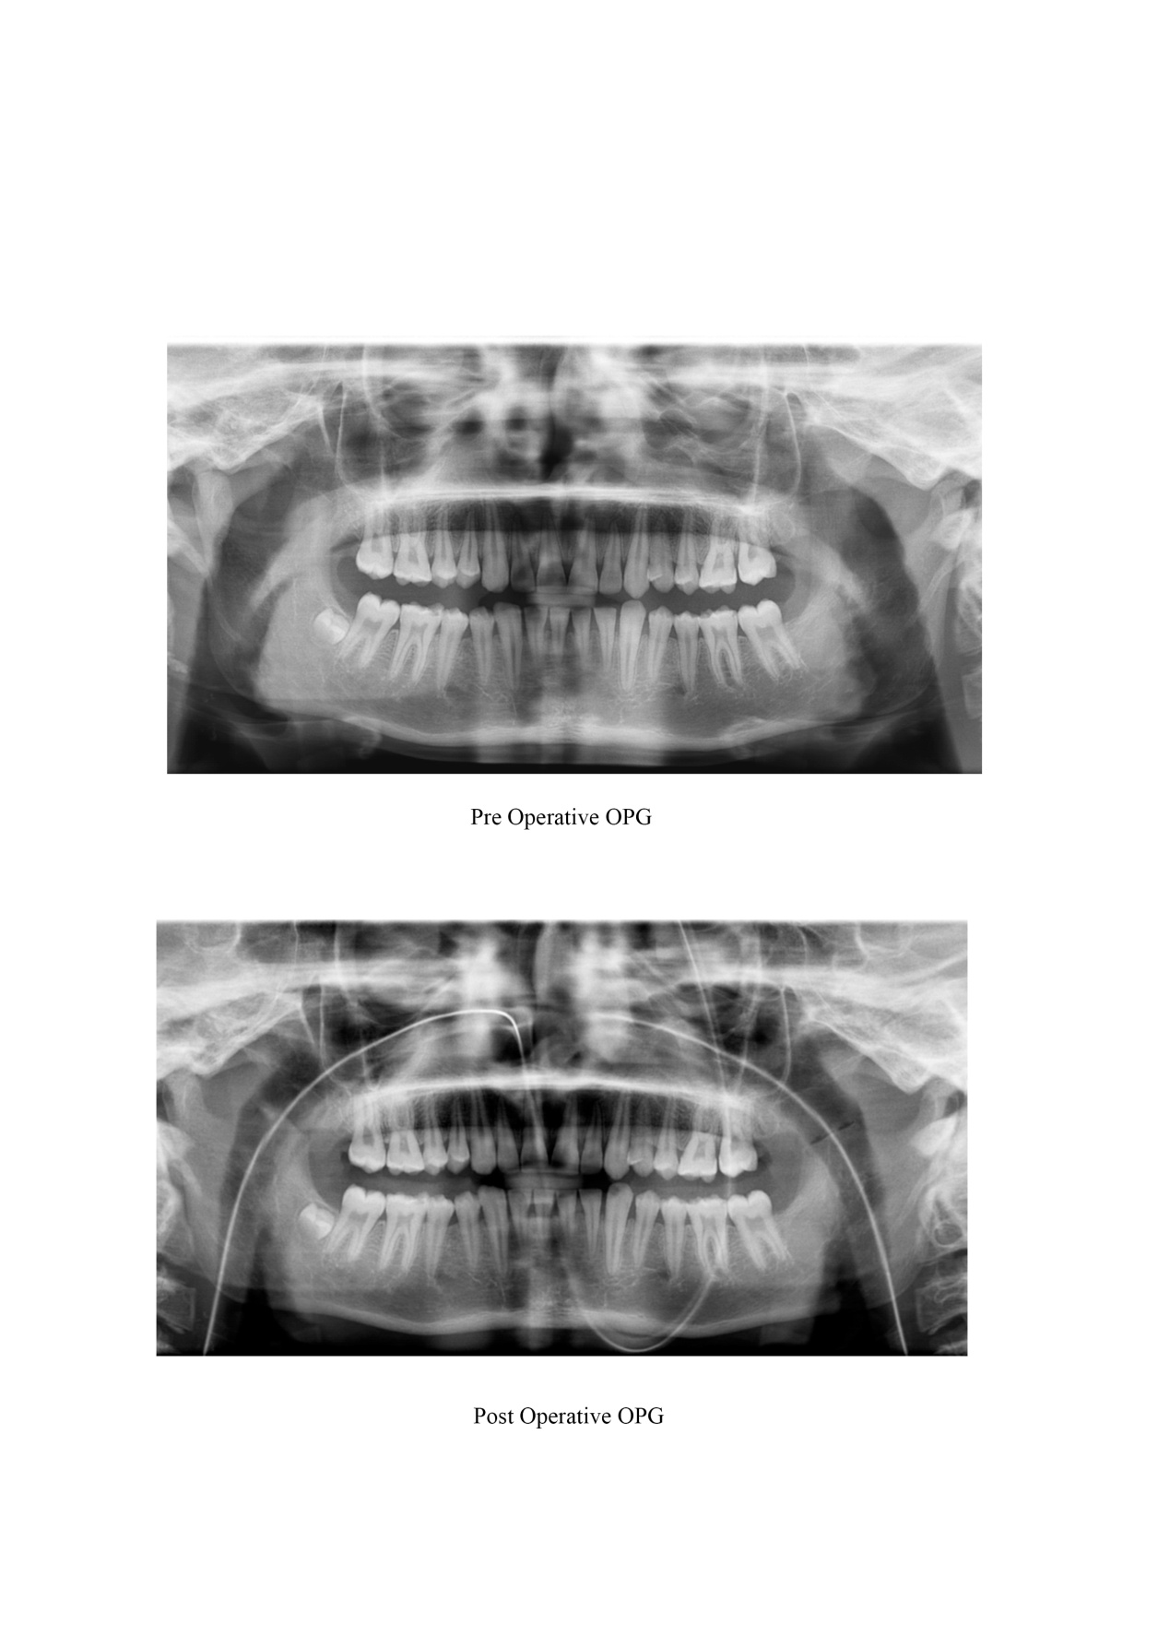
Fig No. 3.34 Pre-Operative OPG

Fig No. 3.35 Post-Operative OPG

CASE 3
PRE-OPERATIVE PHOTOGRAPHS
Right TMJ Ankylosis (Without Coronoidectomy)

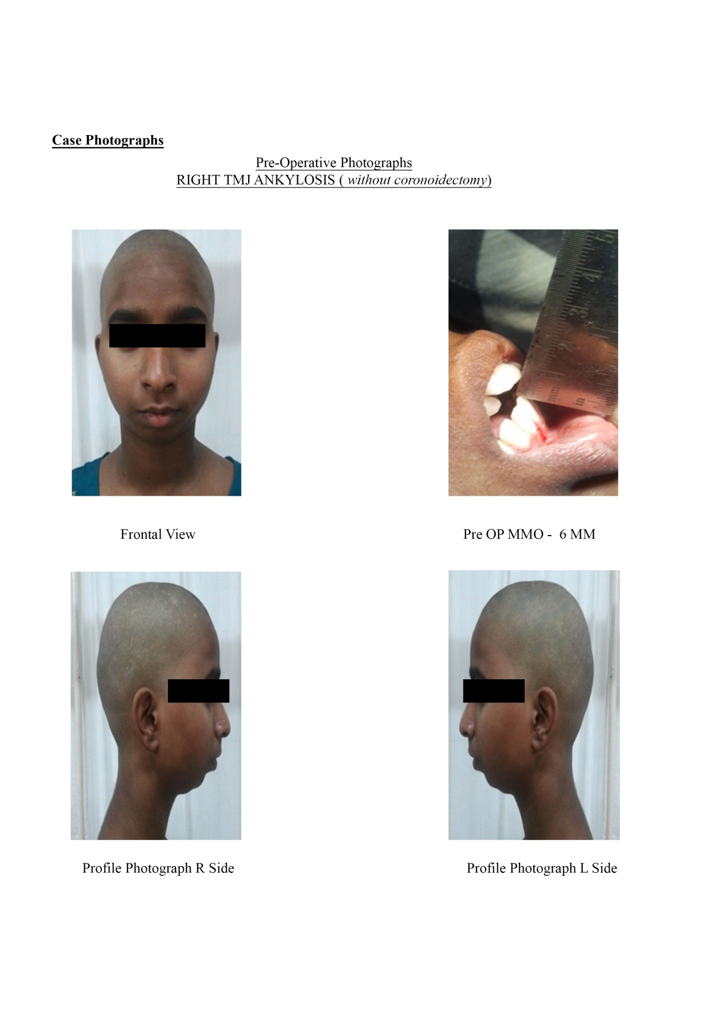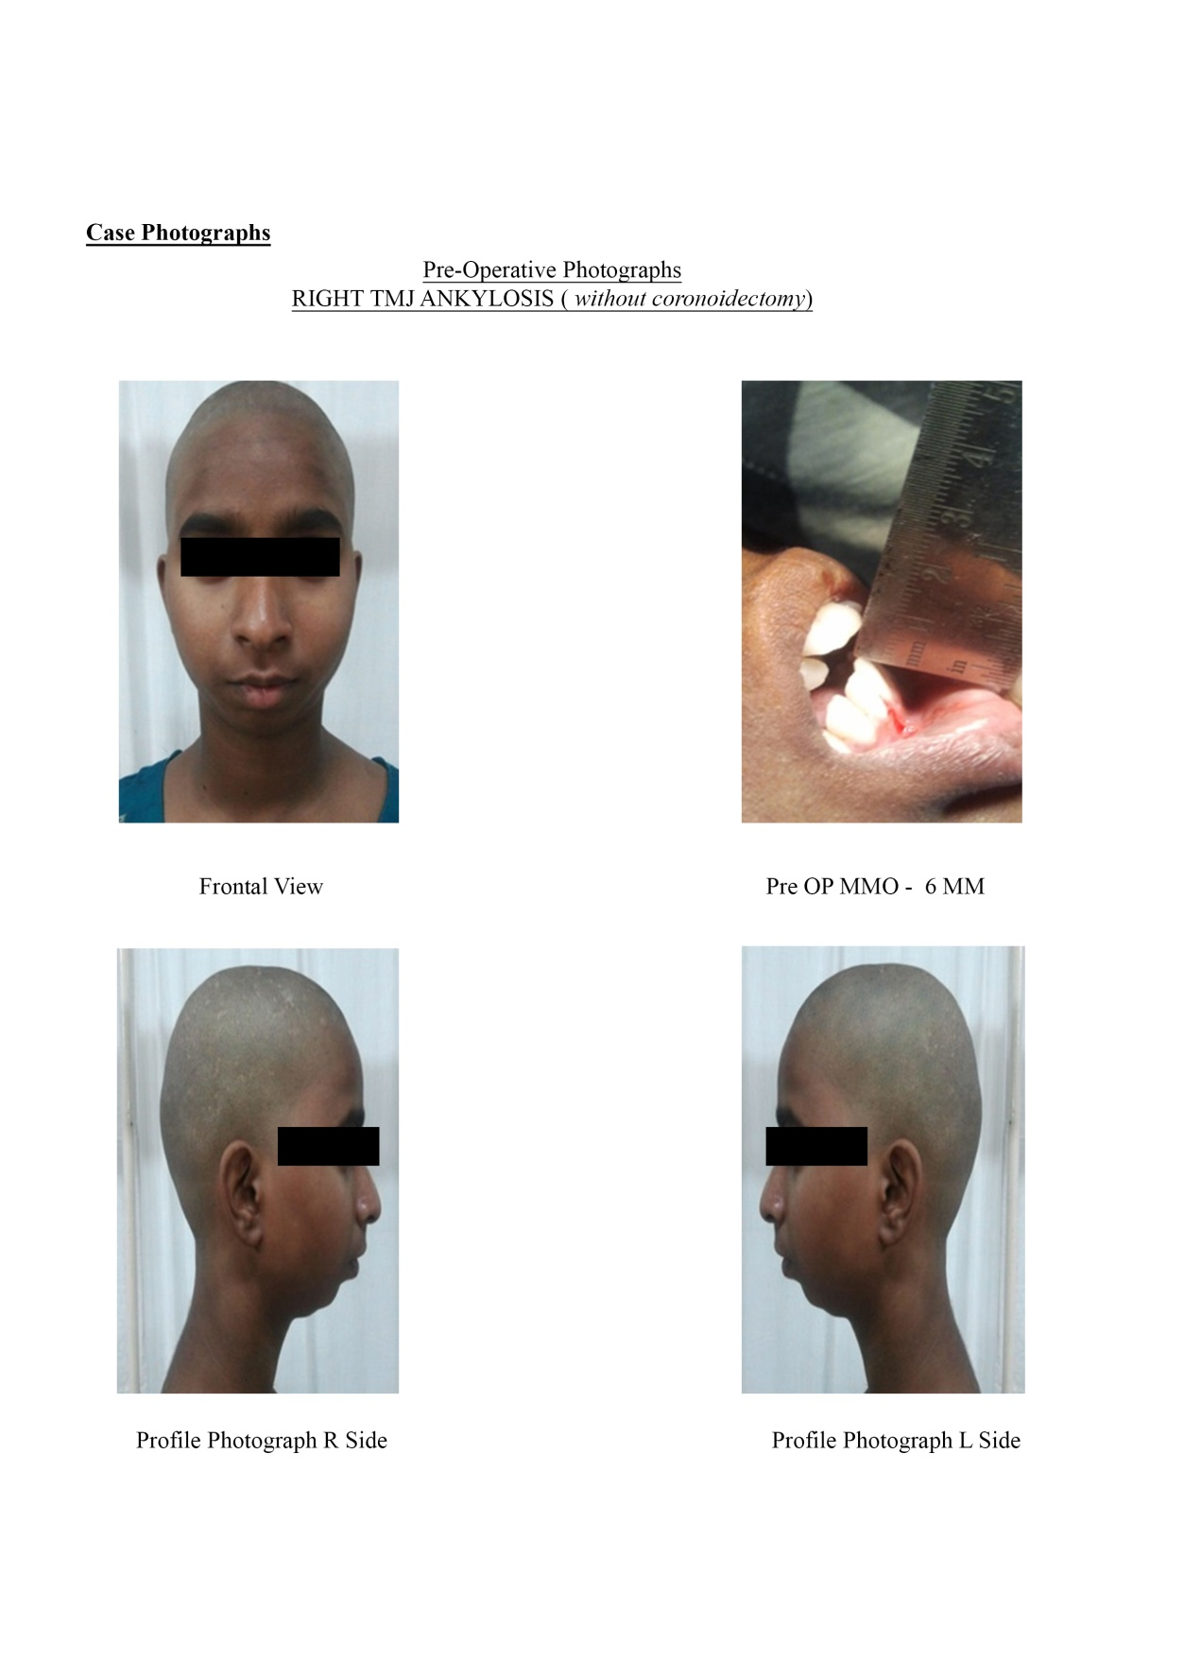
Fig No. 3.36 Frontol View Fig No. 3.37 Pre-Operative MMO

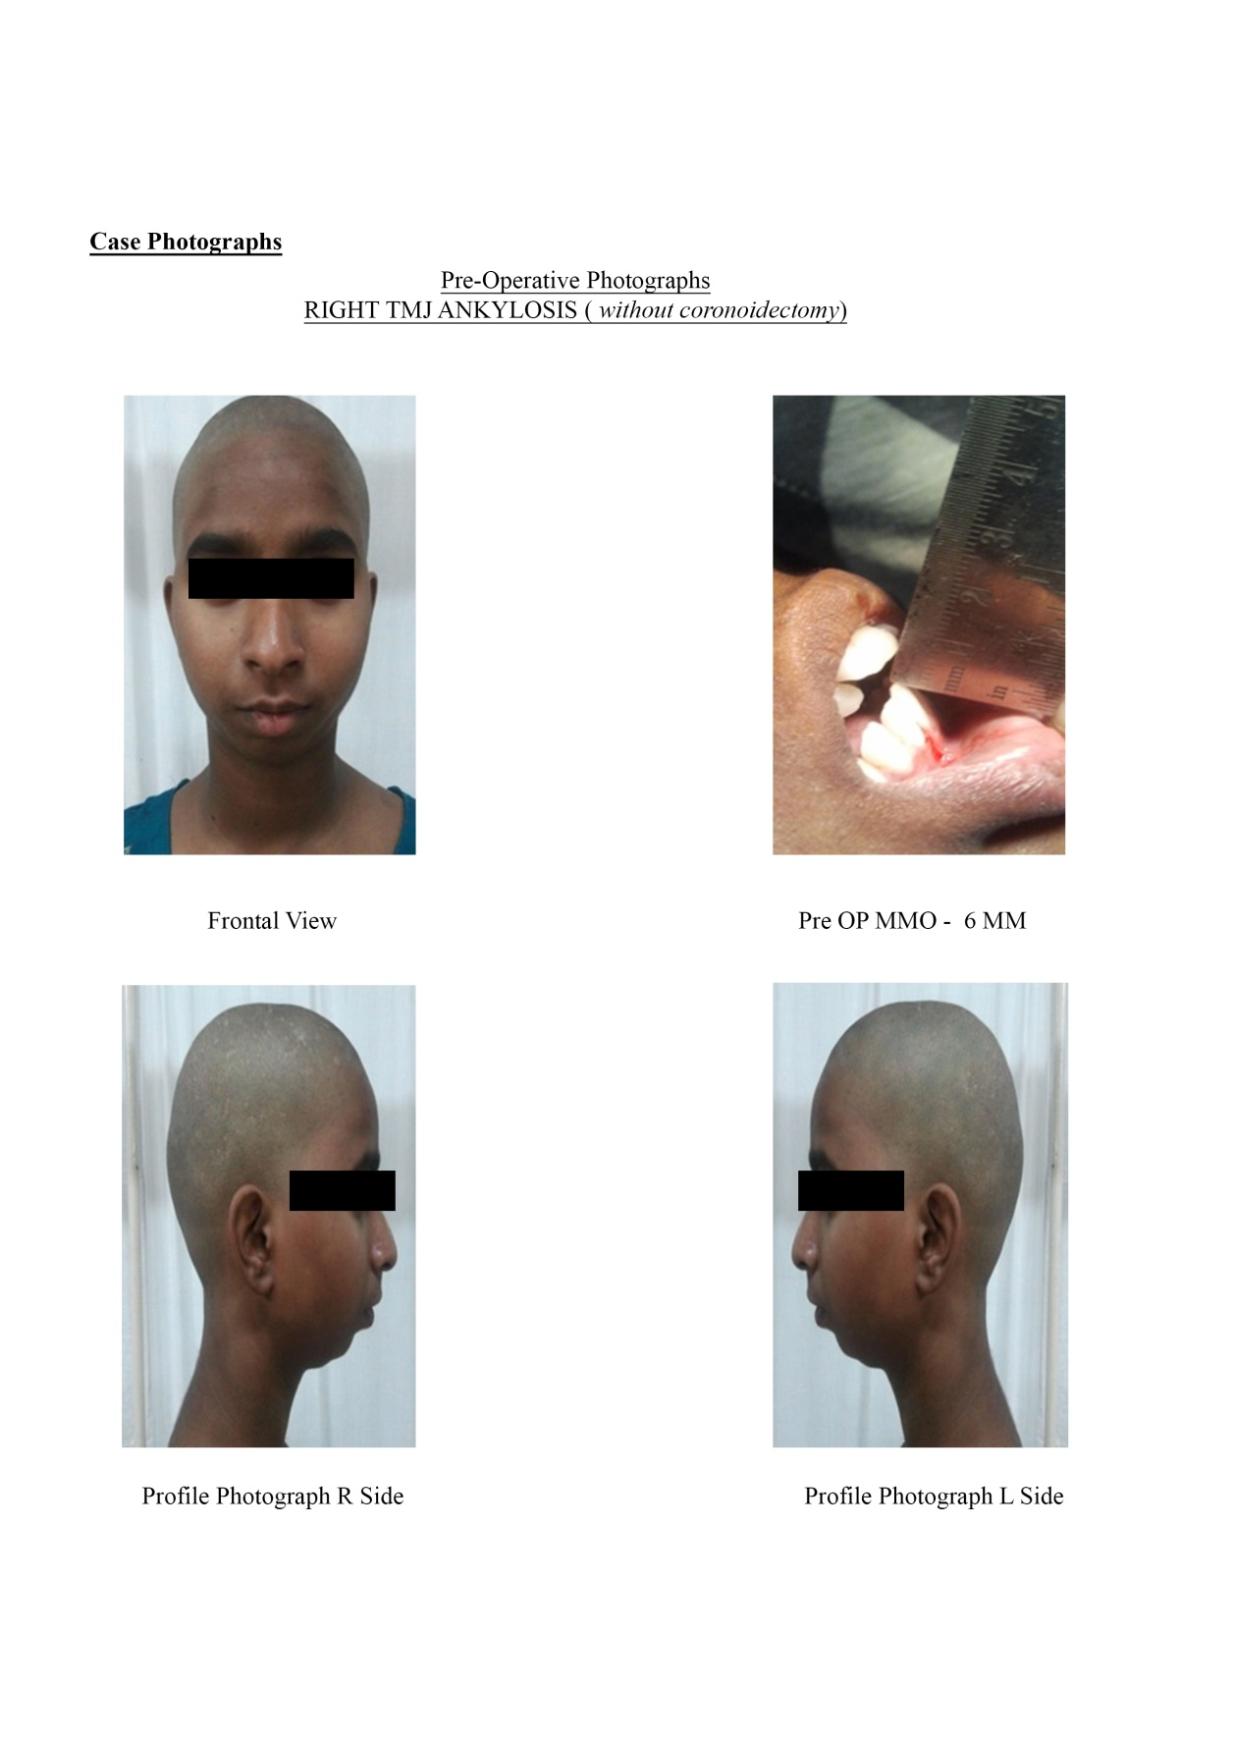
Fig No. 3.38 Profile Photographs Fig No. 3.39 Profile Photographs
R Side L Side

PRE-OPERATIVE RADIOGRAPHS

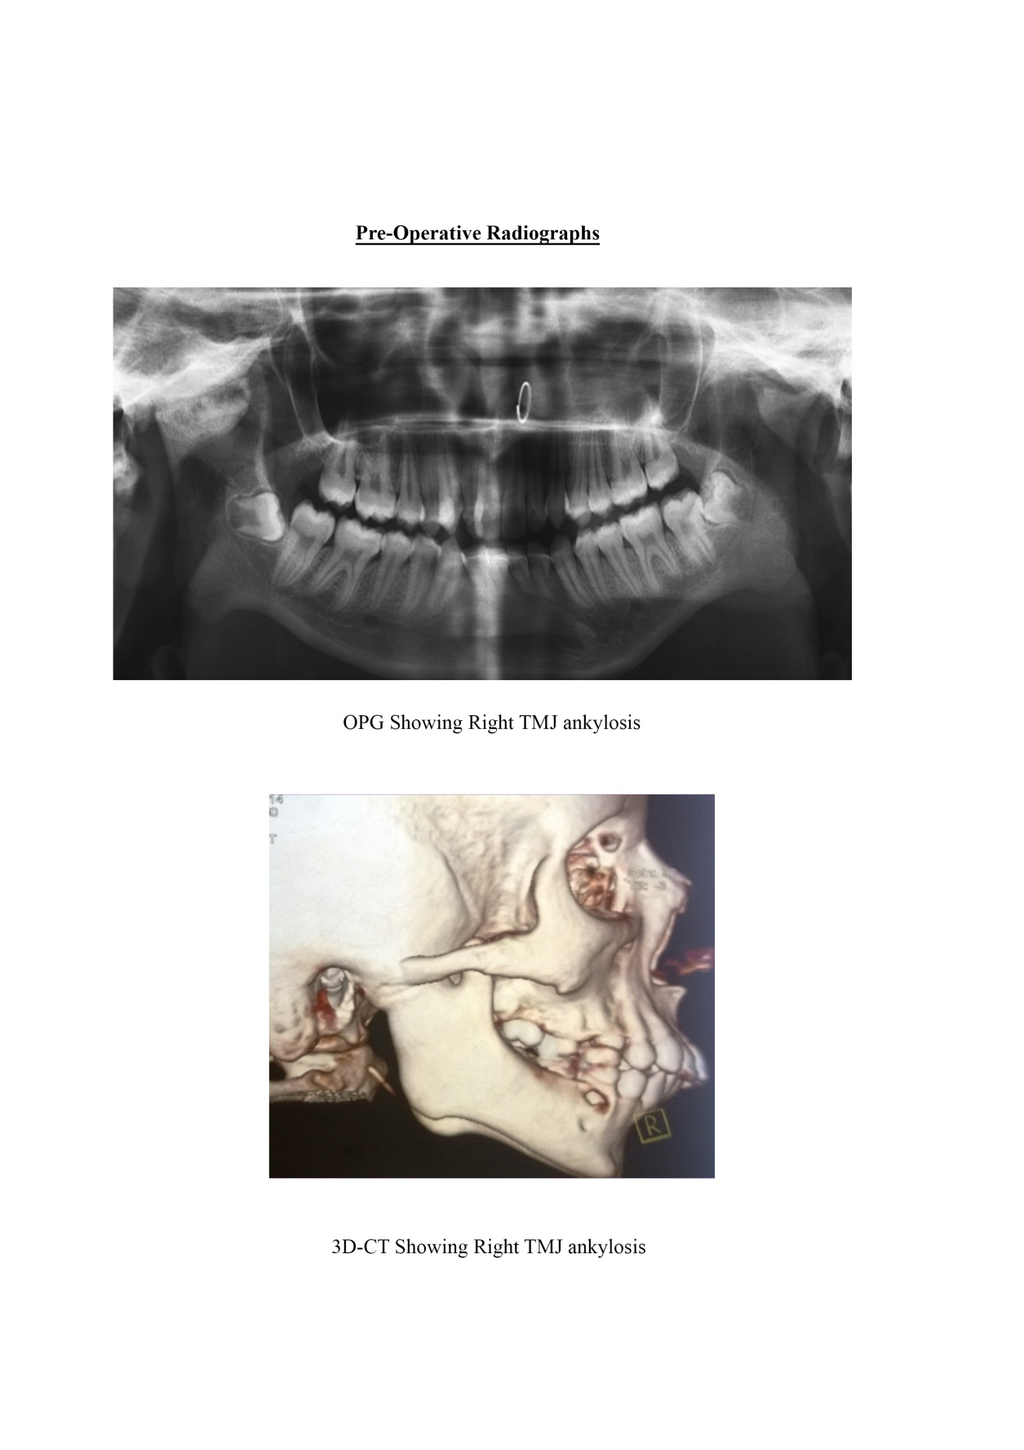
Fig No. 3.40 OPG Showing Right TMJ Ankylosis

Fig No. 3.41 3D-CT Showing Right TMJ Ankylosis

INTRA-OPERATIVE PHOTOGRAPHS

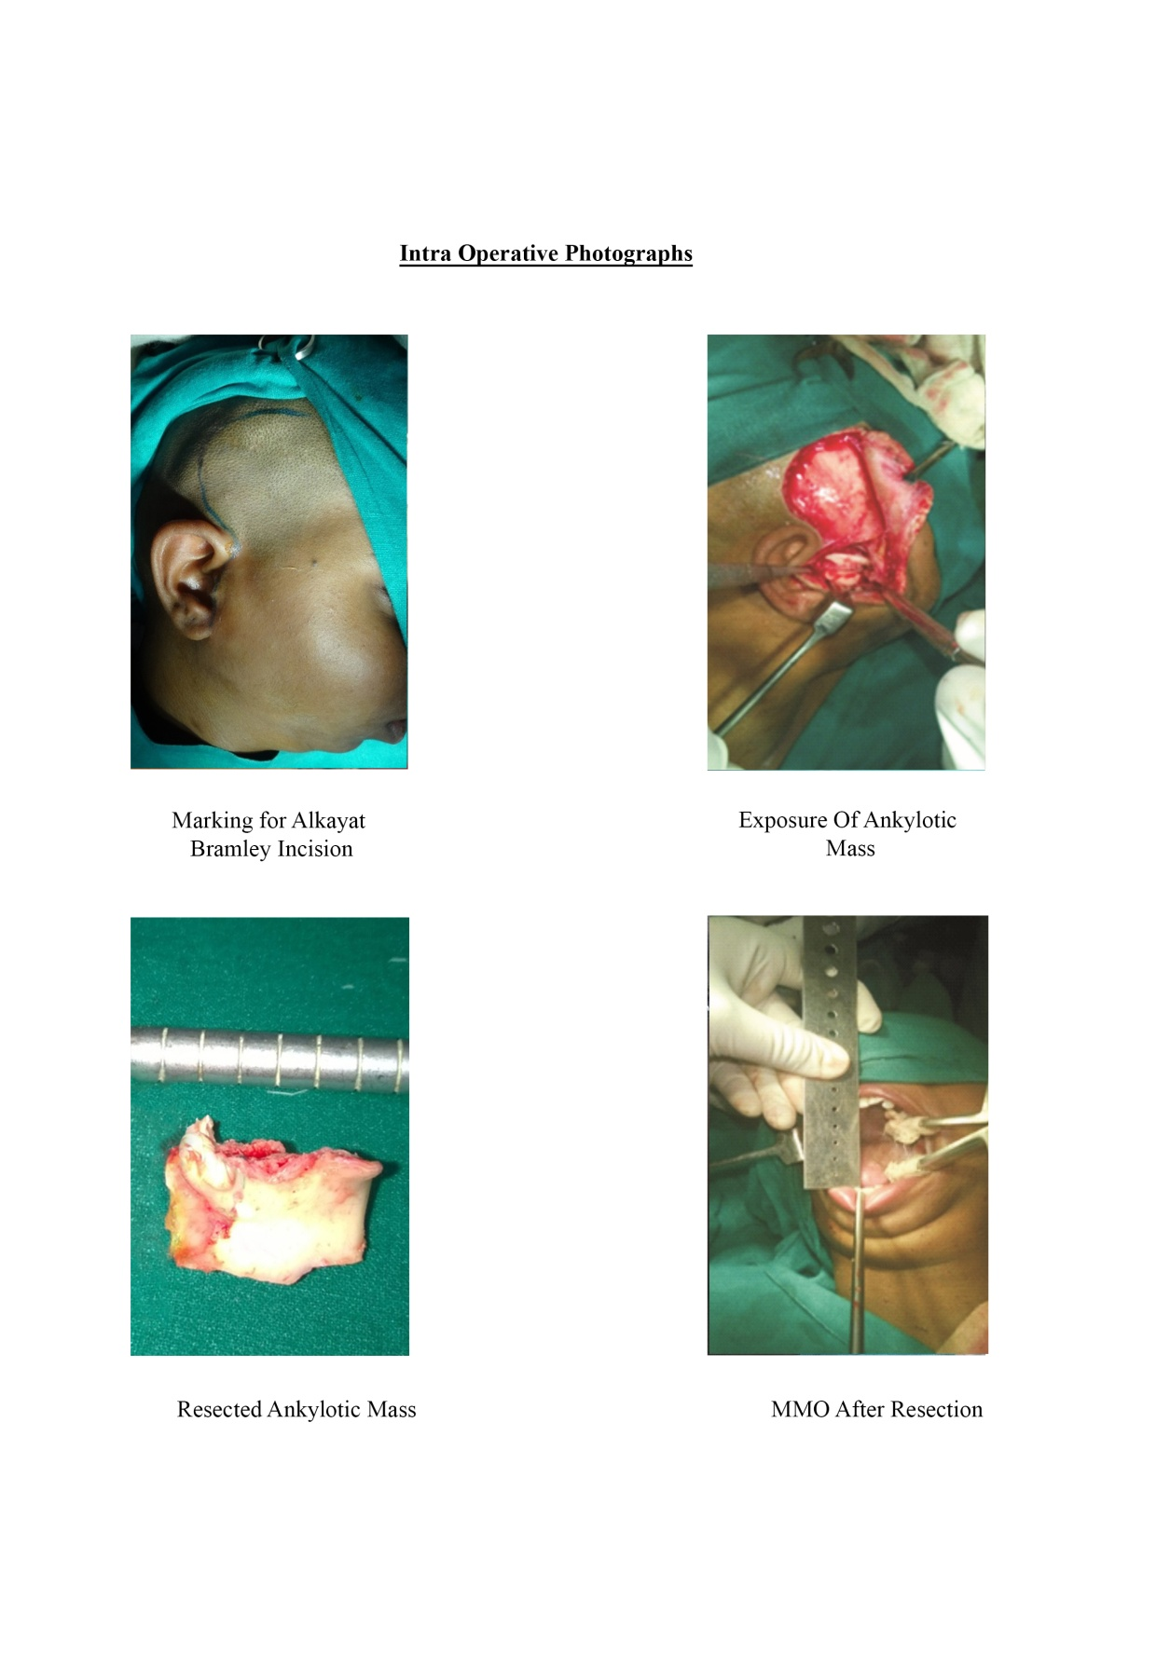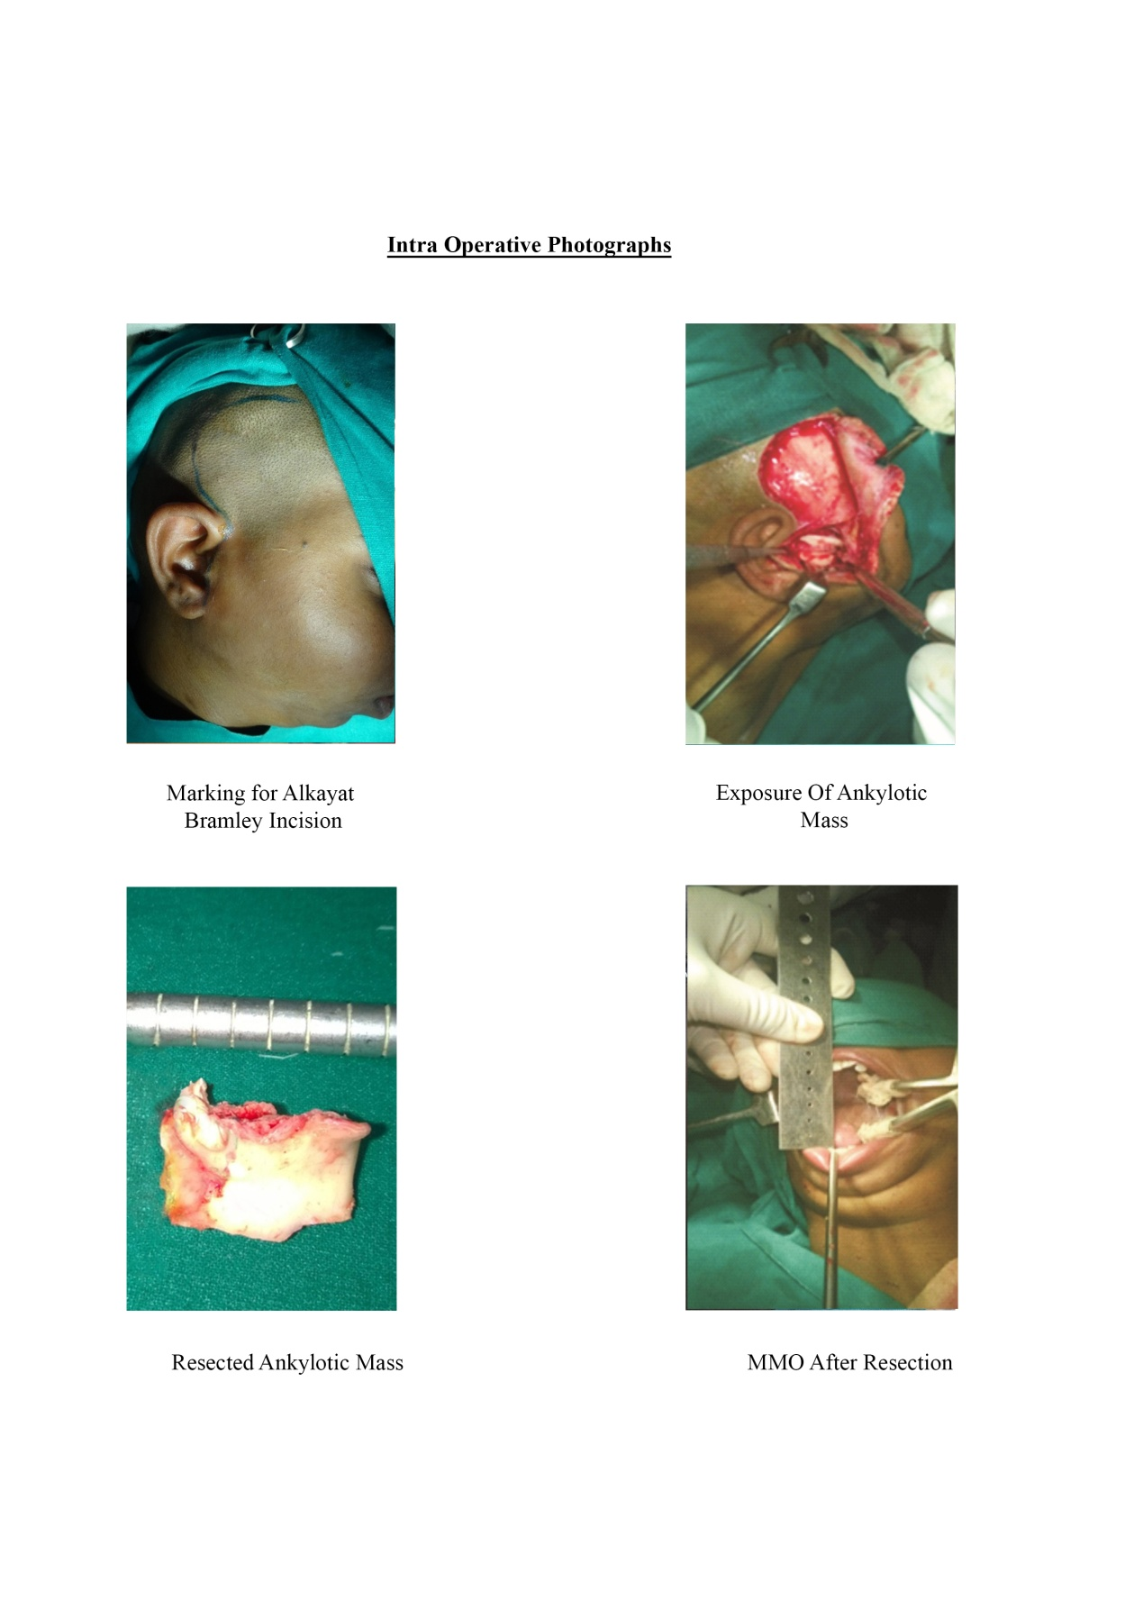
Fig No. 3.42 Marking for Alkayat Fig No. 3.43 Exposure of Ankylotic
Bramley Incision Mass

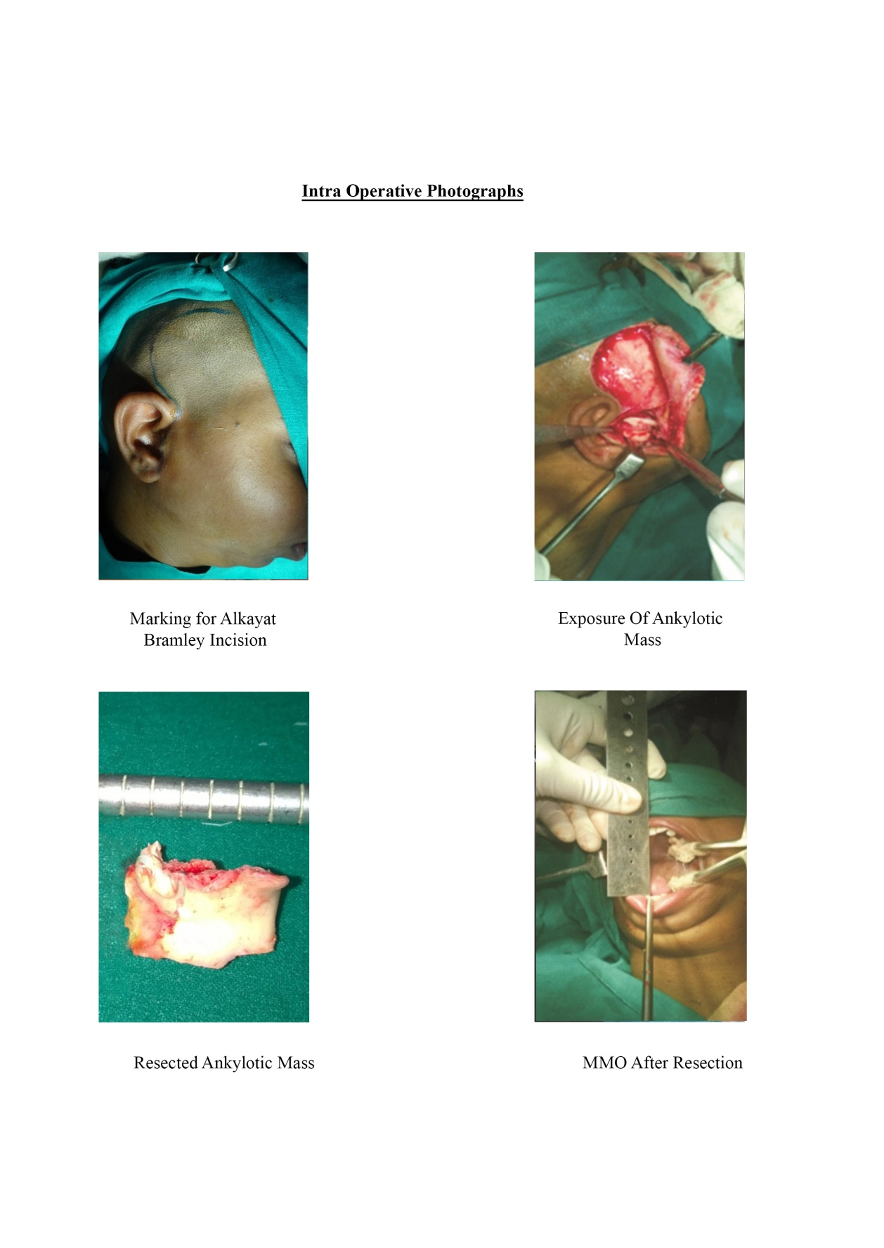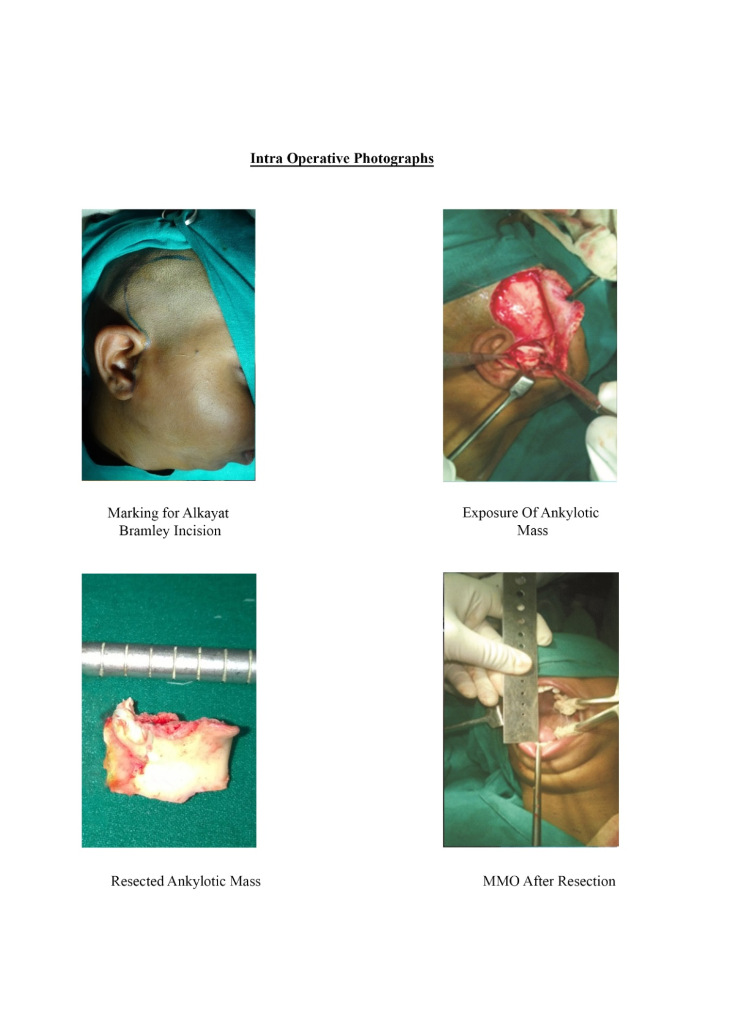
Fig No. 3.44 Resected Ankylotic Mass Fig No. 3.45 MMO after Resection

FOLLOW UP

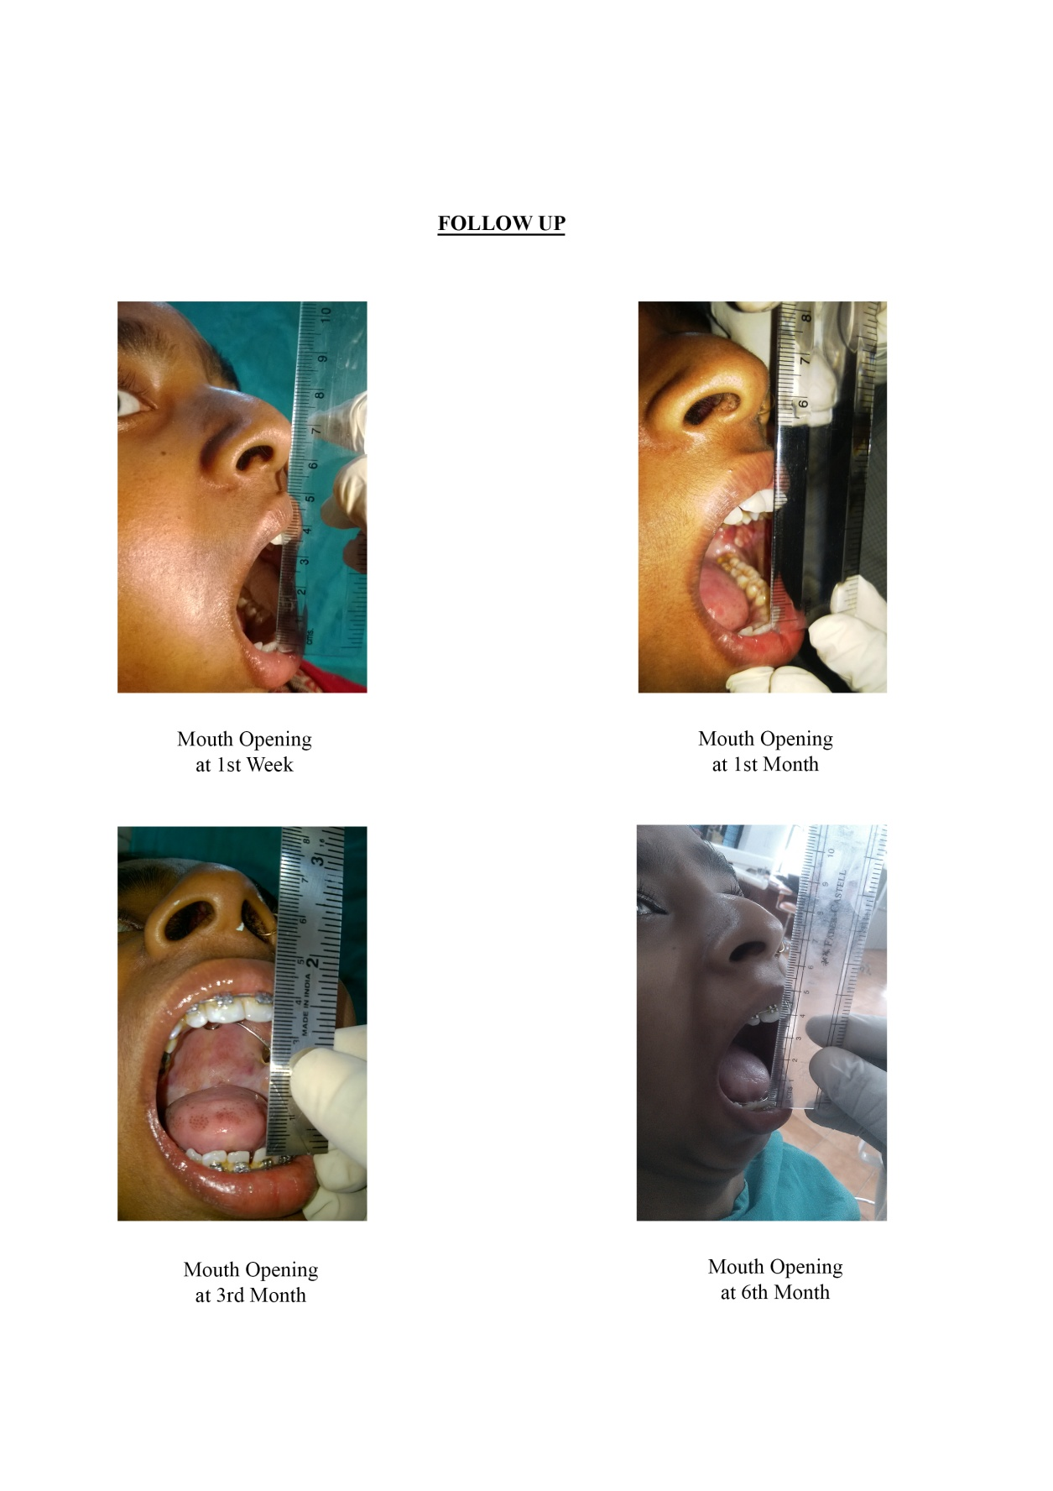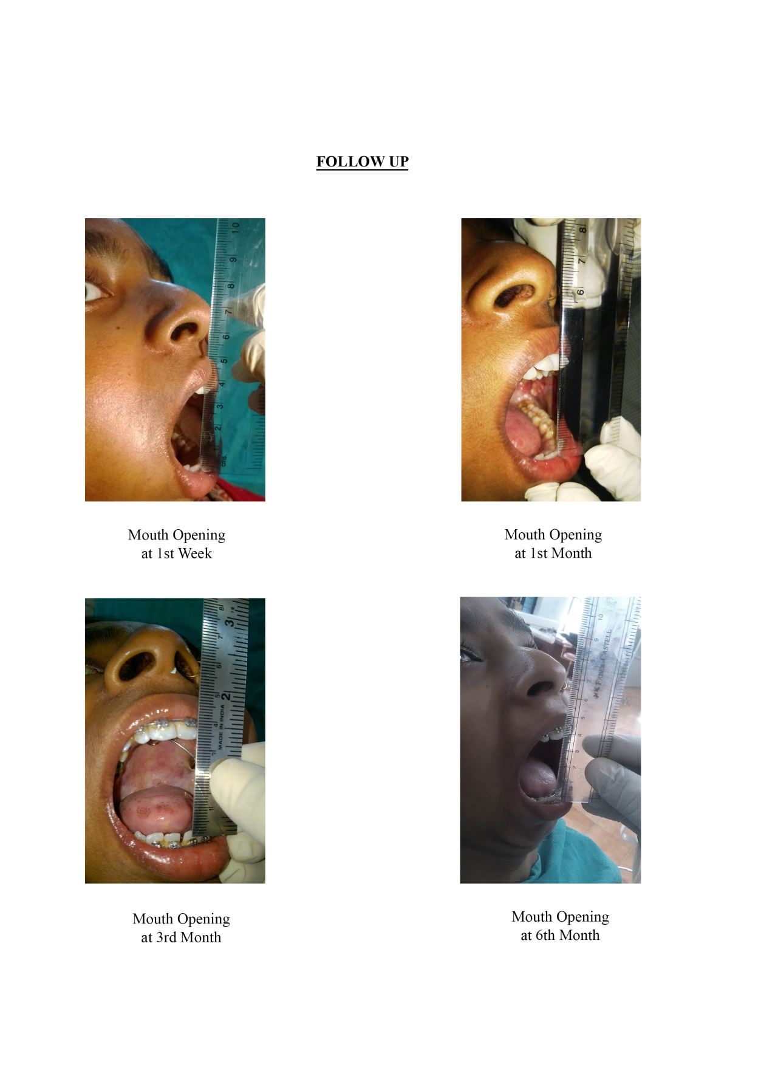
Fig No. 3.46 Mouth Opening at Fig No. 3.47 Mouth Opening at
1st Week 1st Month

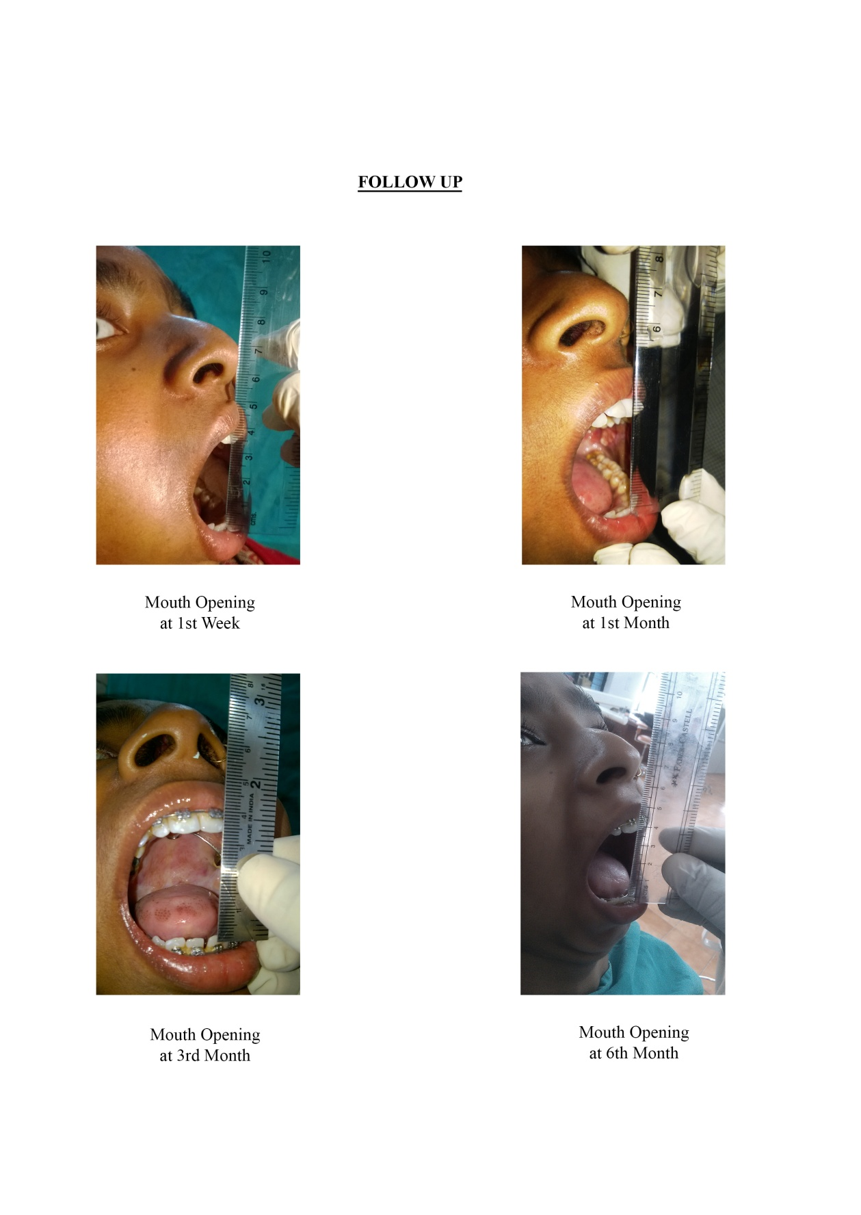
Fig No. 3.48 Mouth Opening at Fig No. 3.49 Mouth Opening at
3rd Month 6th Month

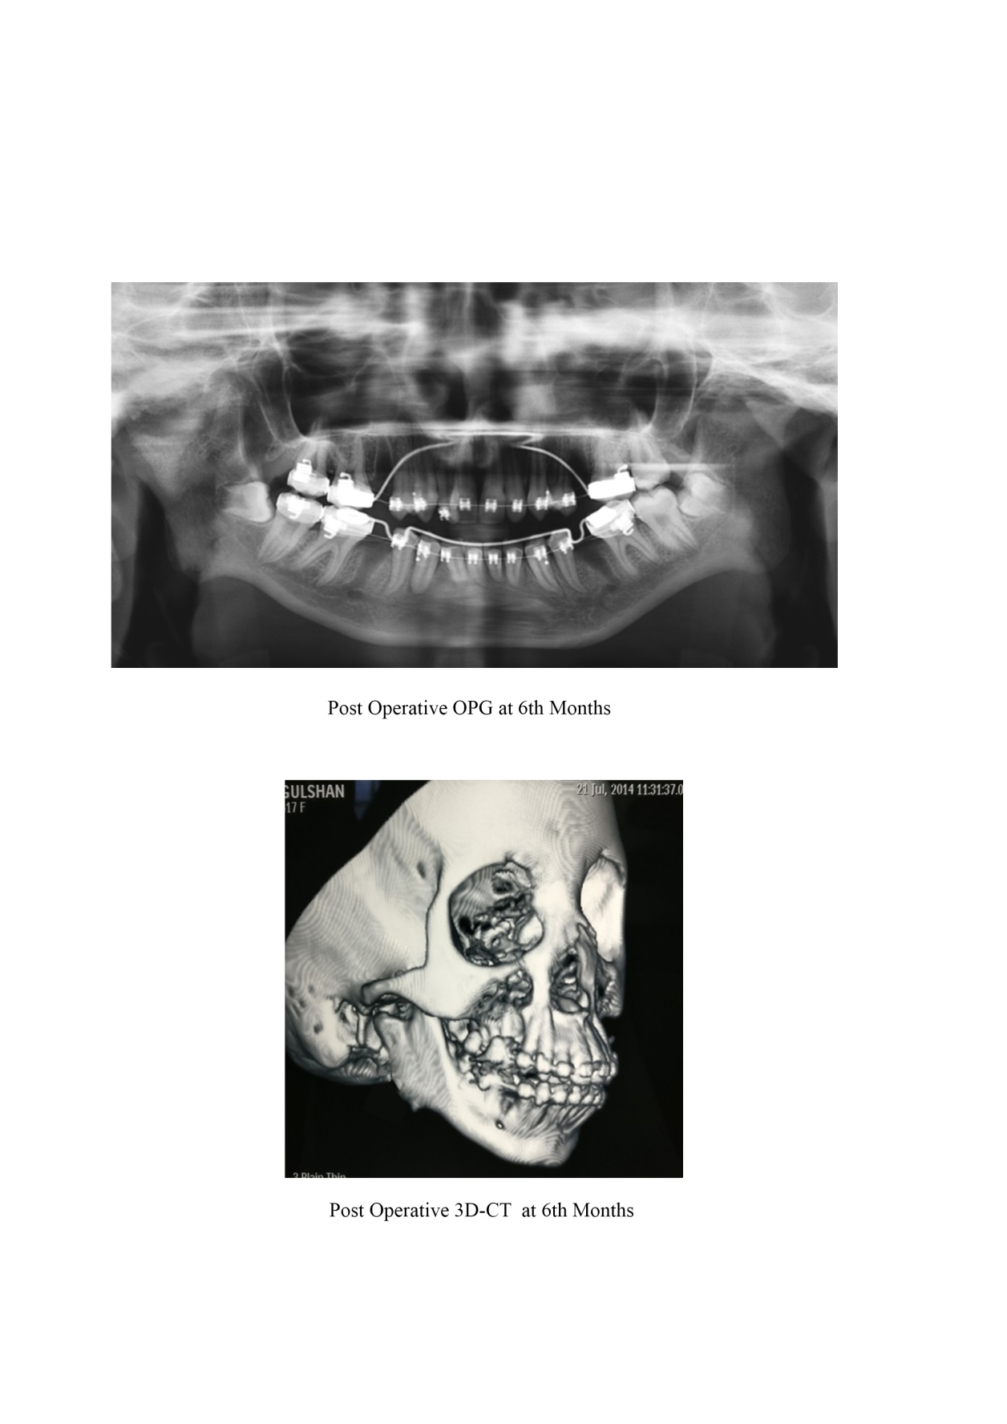

Fig No. 3.50 Post-Operative OPG at 6th Month

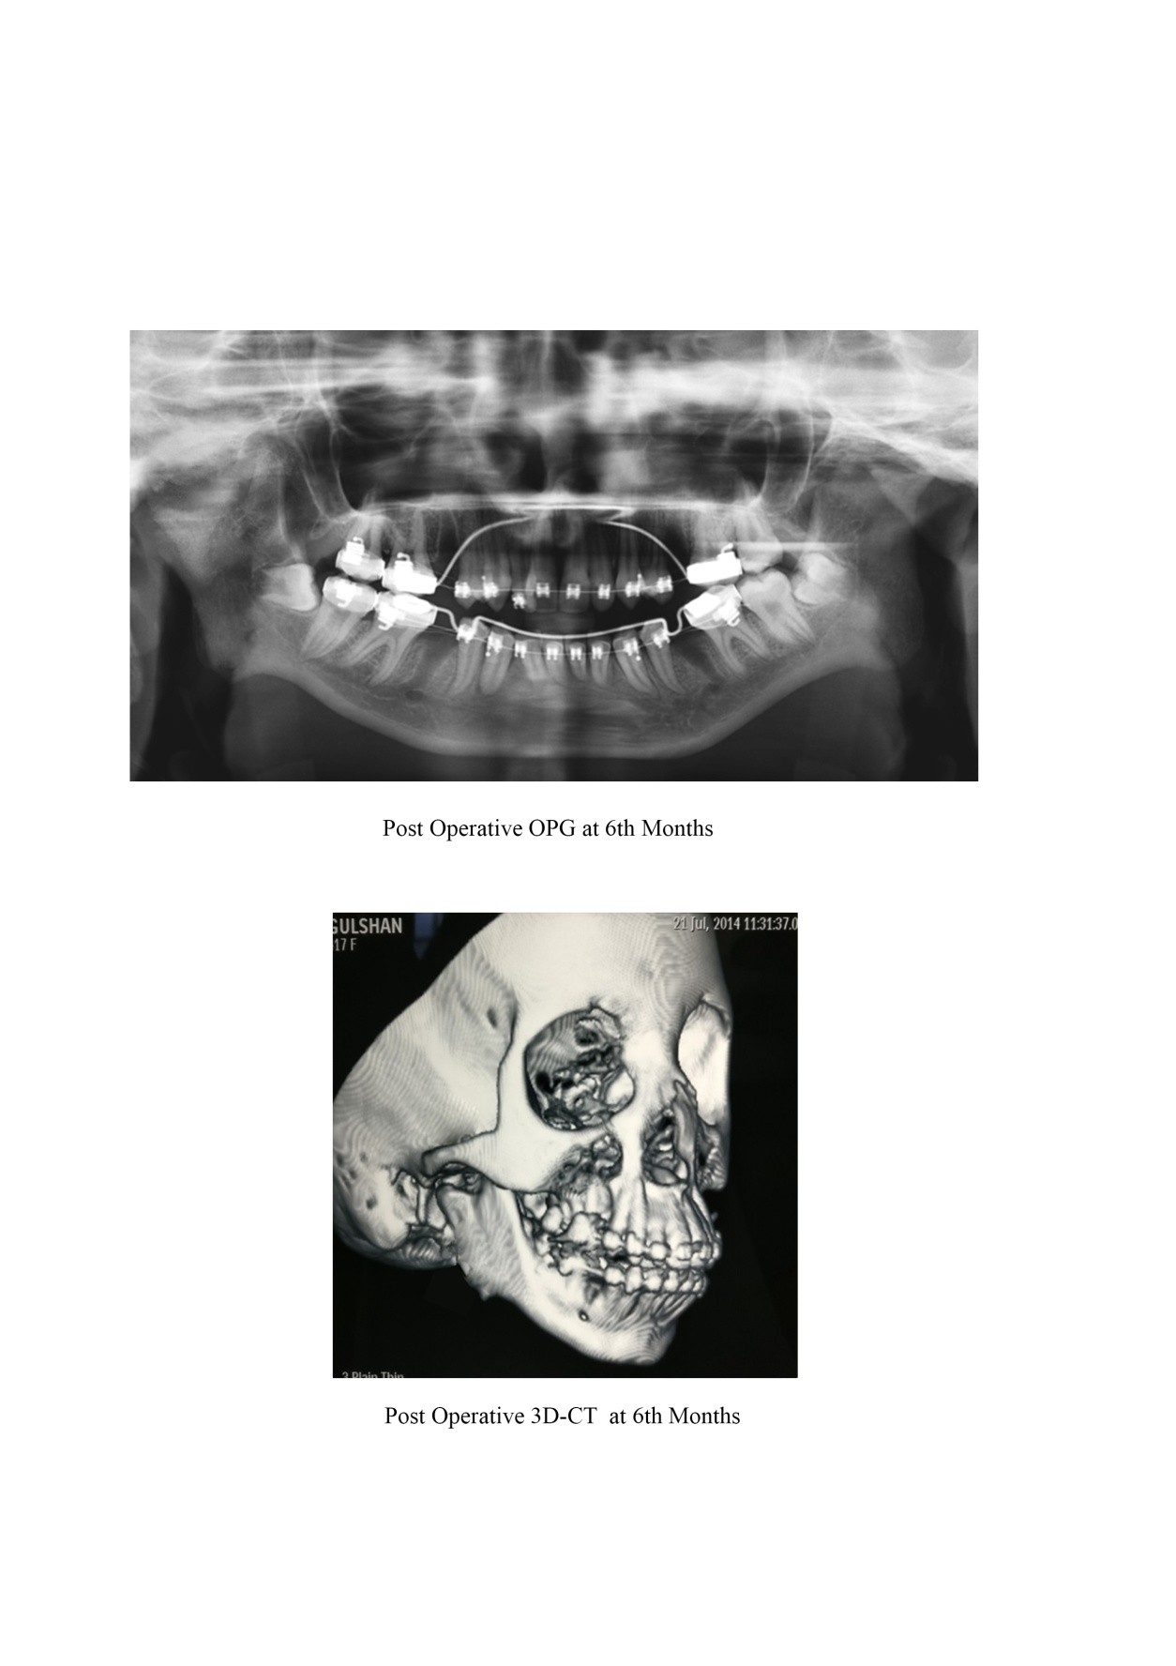
Fig No. 3.51 Post Operative 3D-CT at 6th Month

CASE 4
PRE-OPERATIVE PHOTOGRAPHS
Left TMJ Ankylosis (With Coronoidectomy)

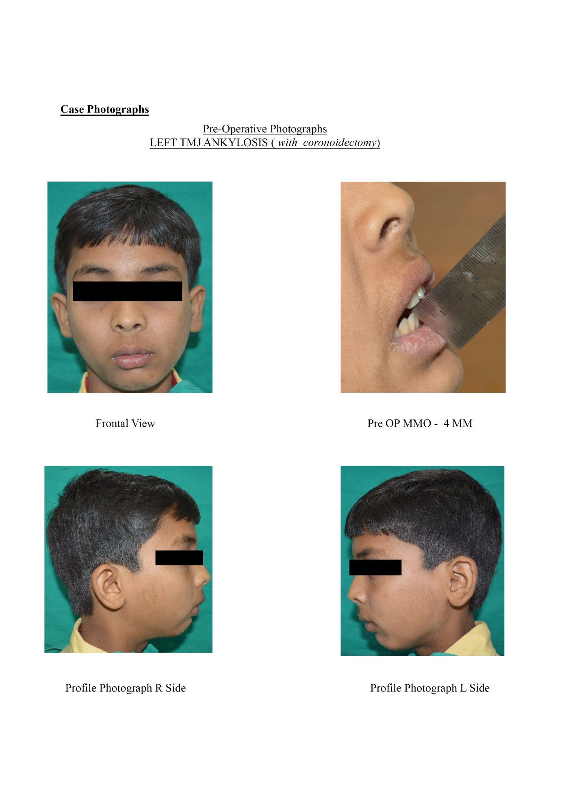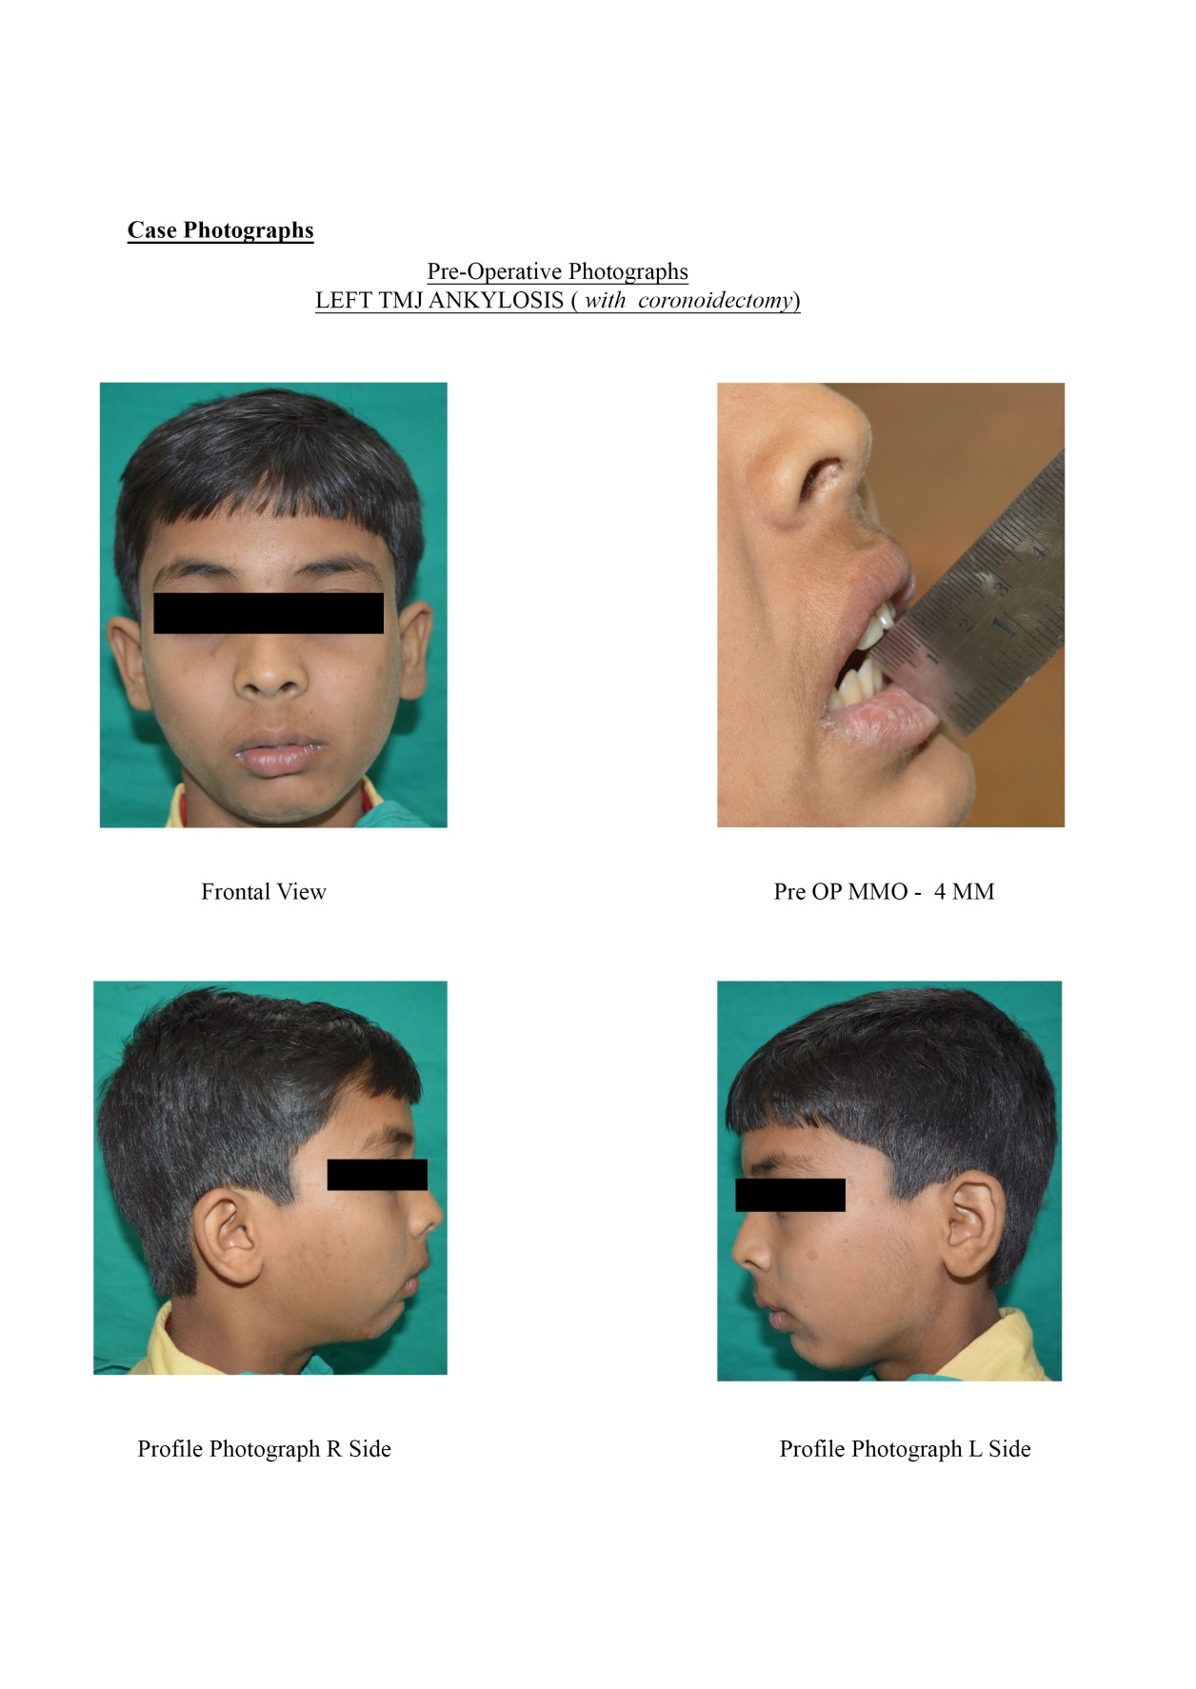
Fig No. 3.52 Frontol View Fig No. 3.53 Pre-Operative MMO

Fig No. 3.54 Profile Photographs Fig No. 3.55 Profile Photographs
R Side L Side

PRE-OPERATIVE RADIOGRAPHS

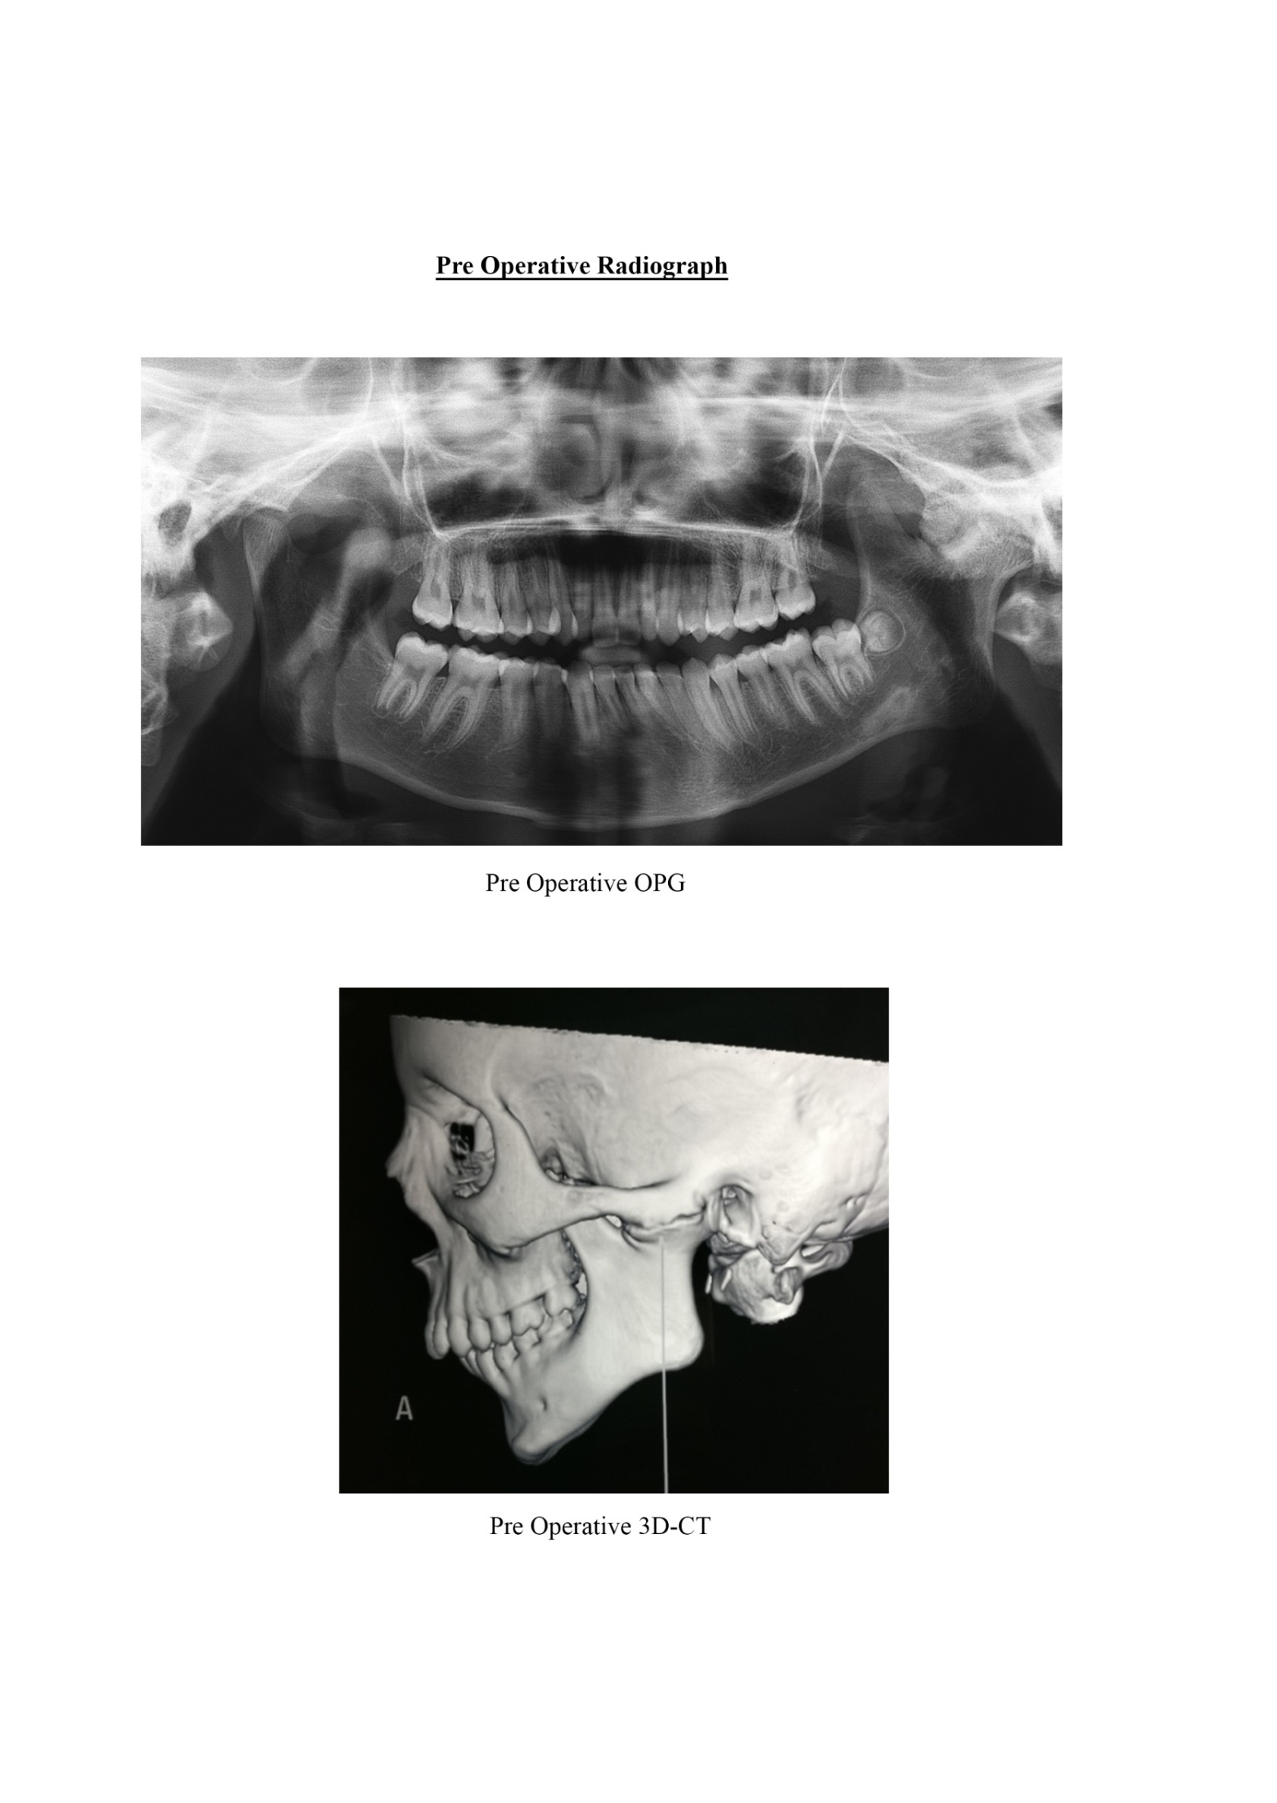
Fig No. 3.56 OPG Showing Left TMJ Ankylosis

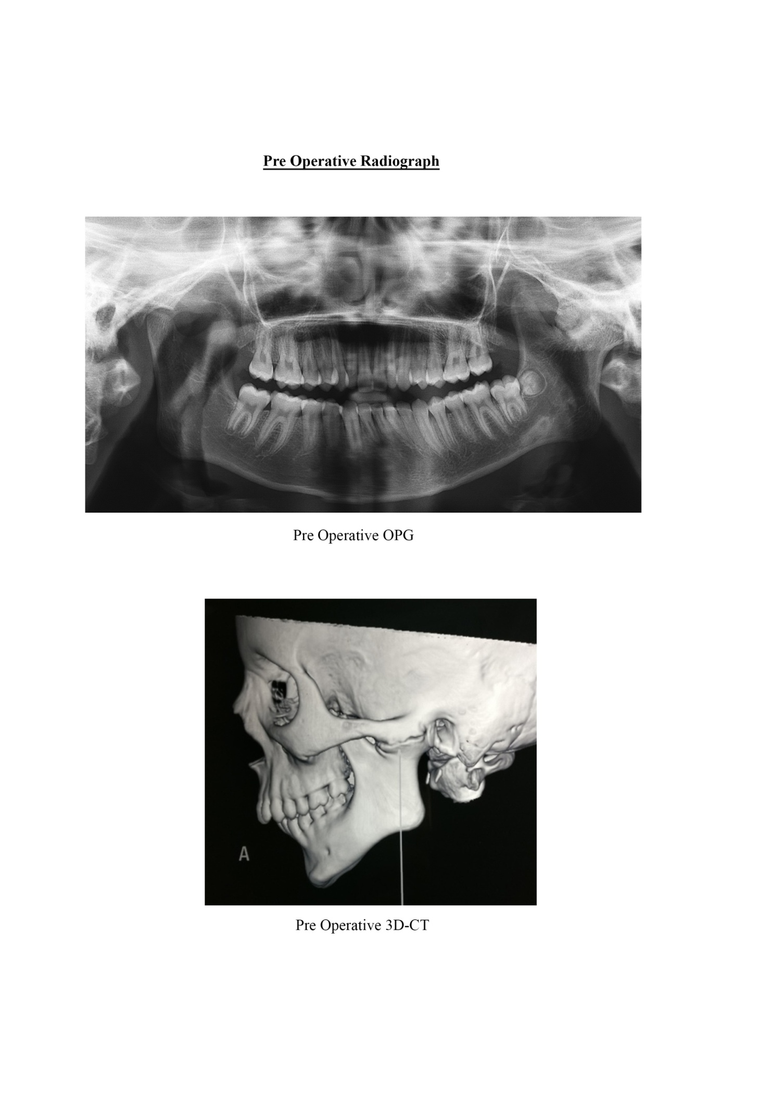
Fig No. 3.57 3D-CT Showing Left TMJ Ankylosis

INTRA-OPERATIVE PHOTOGRAPHS

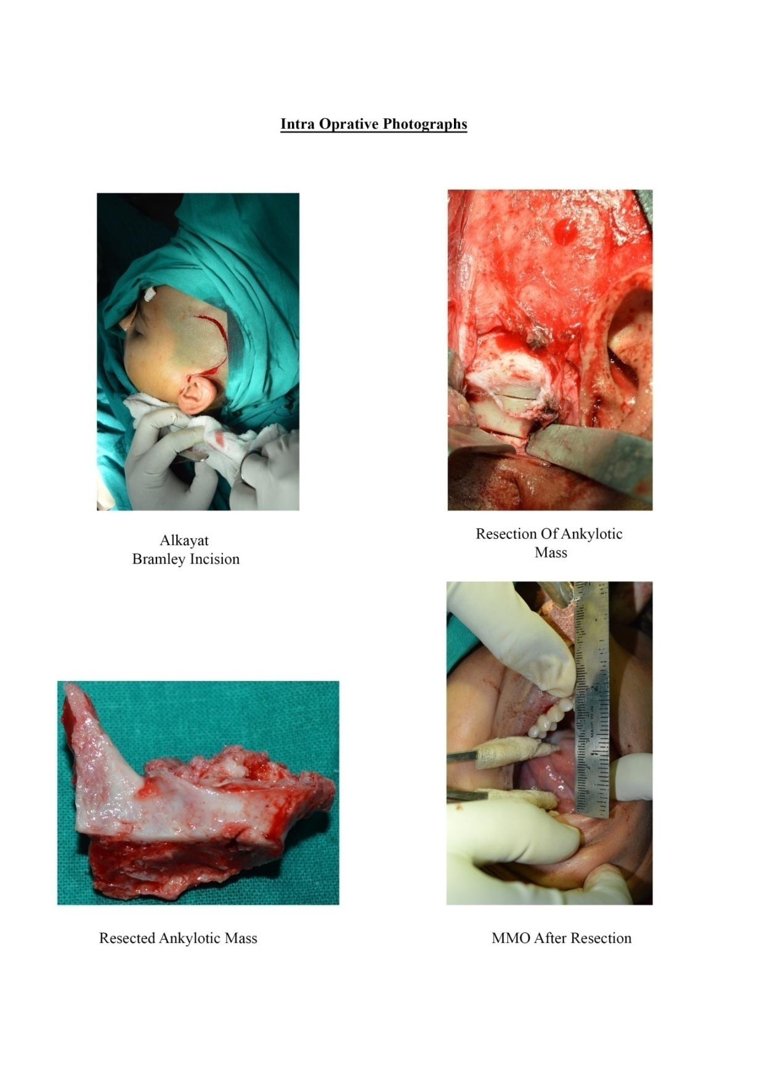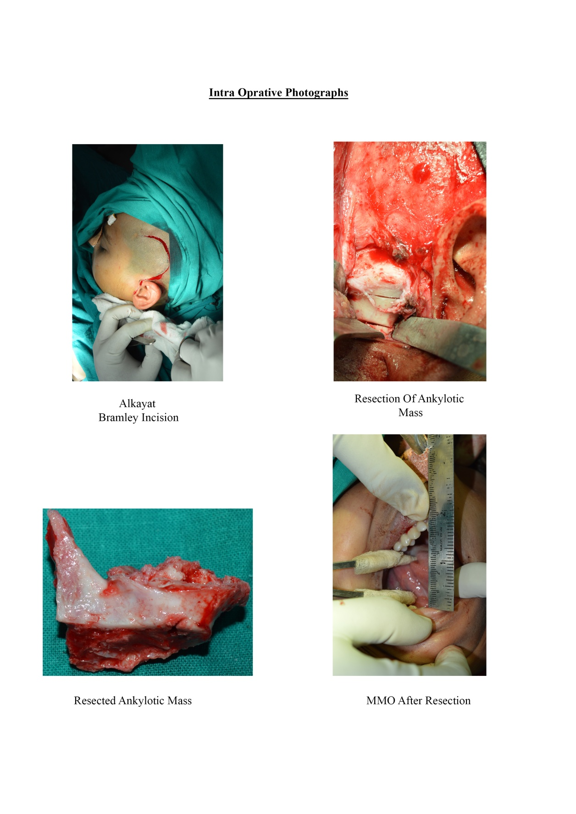
Fig No. 3.58 Alkayat Bramley Incision Fig No. 3.59 Resection of Ankylotic
Mass

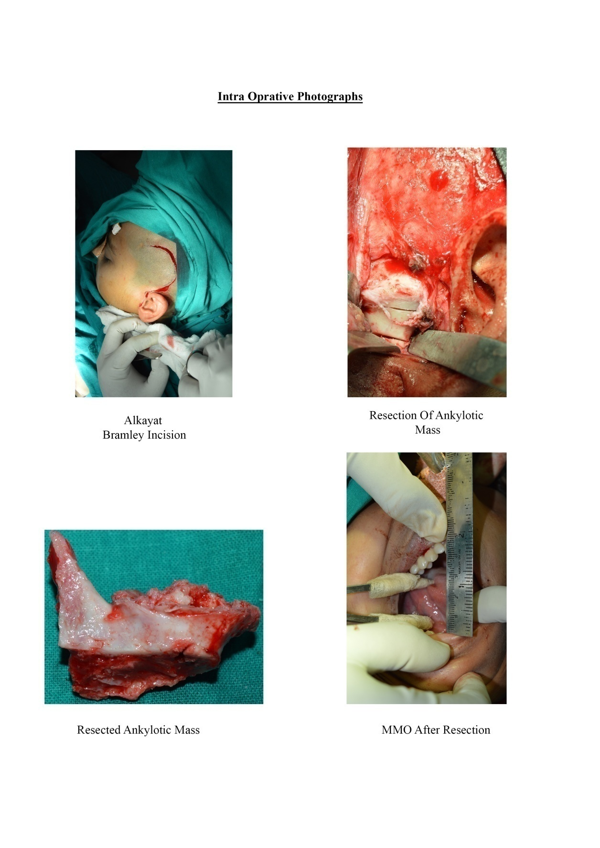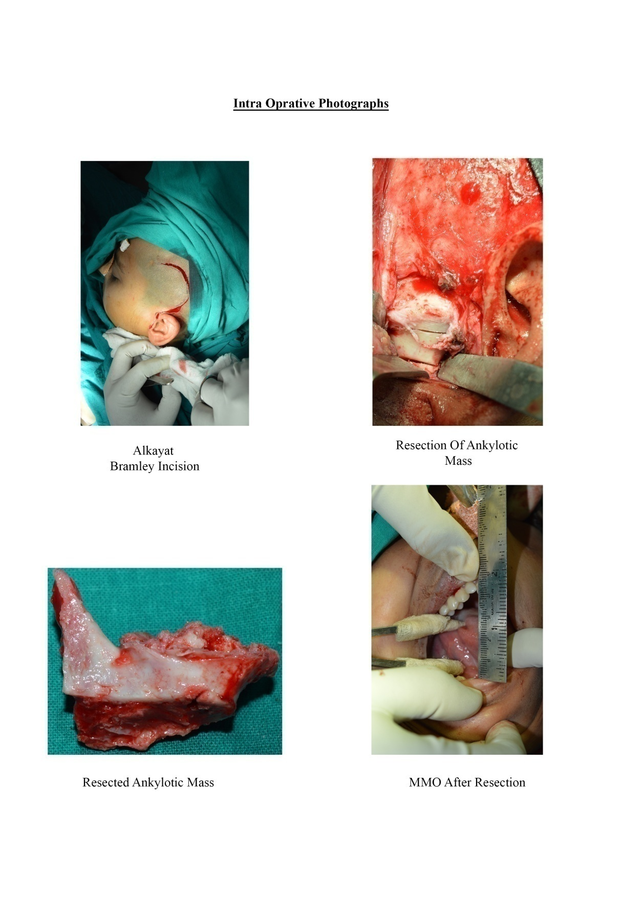
Fig No. 3.60 Resected Ankylotic Mass Fig No. 3.61 MMO after Resection

FOLLOW UP

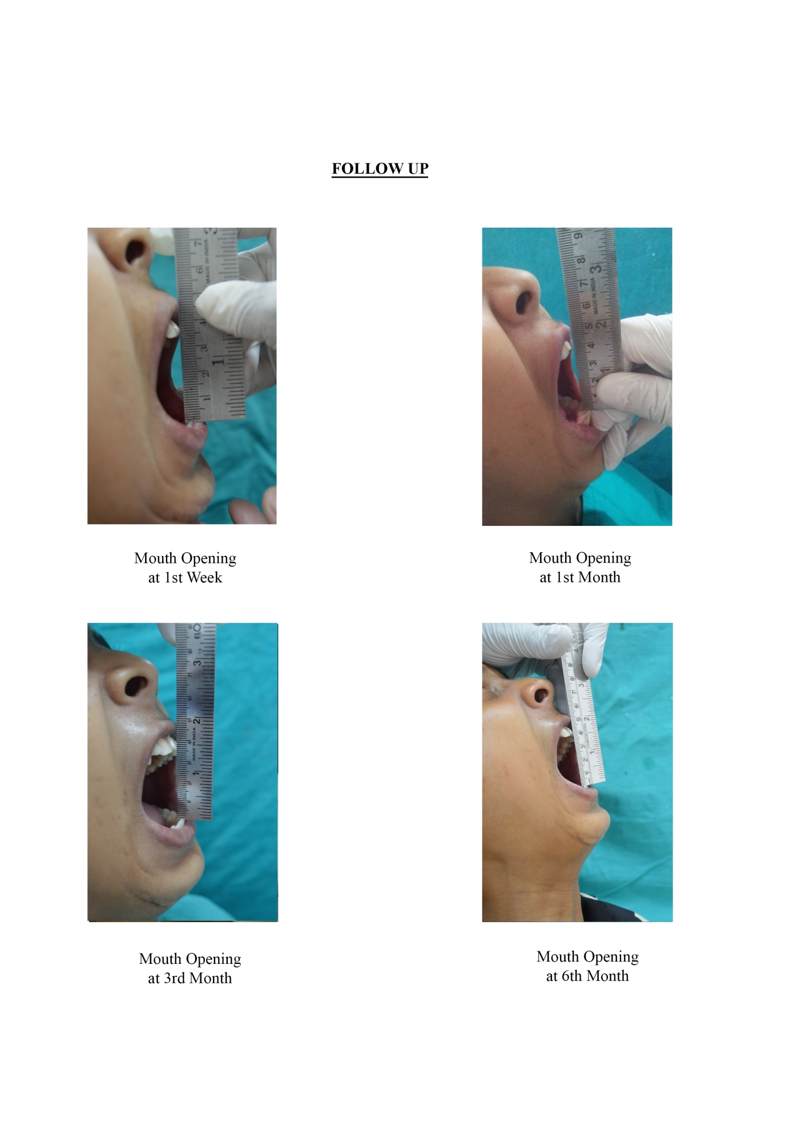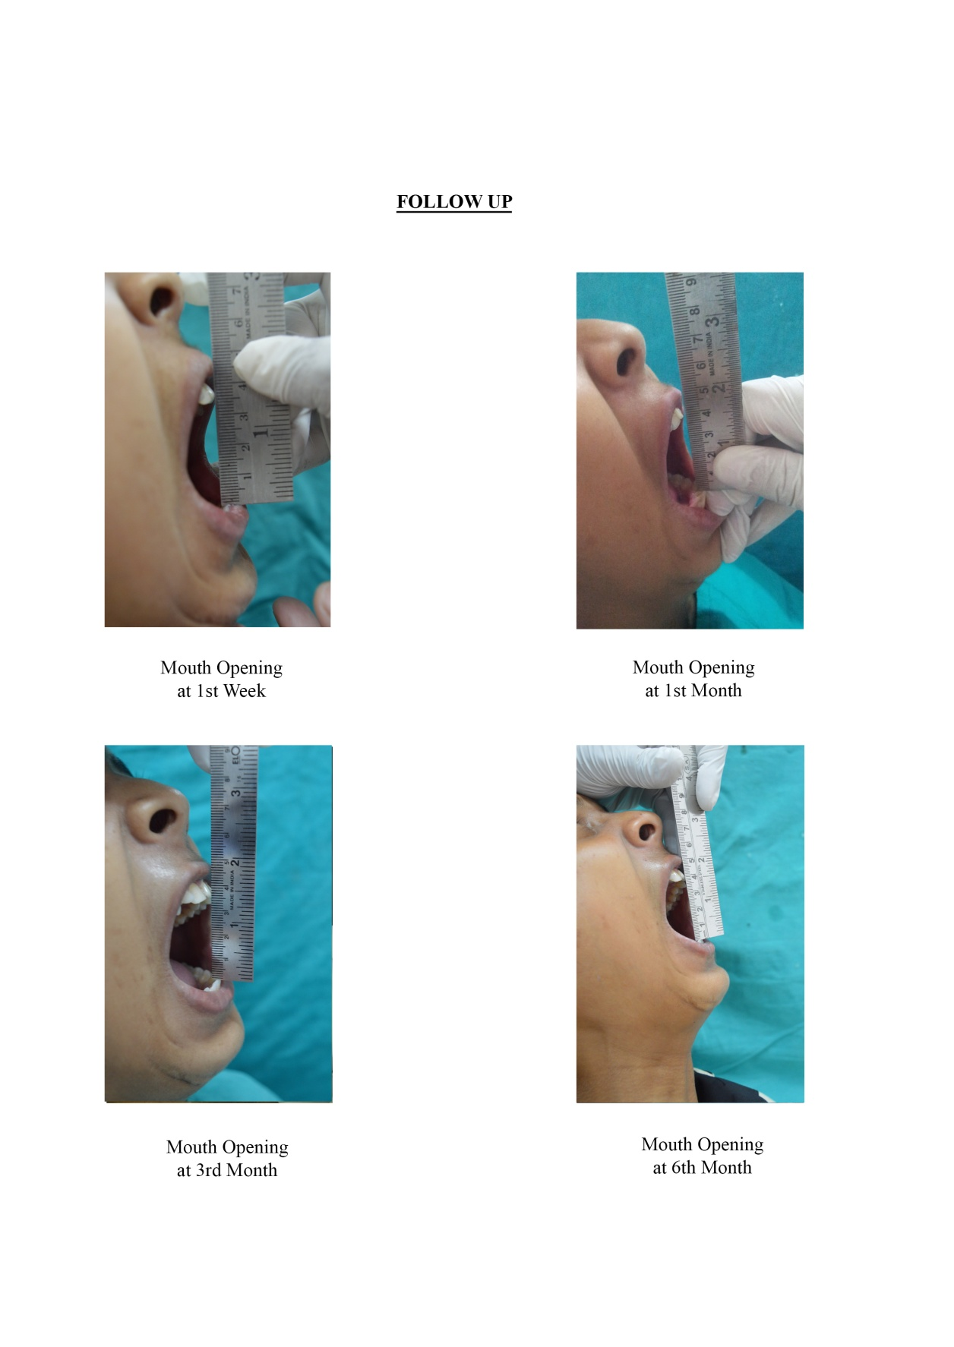
Fig No. 3.62 Mouth Opening at Fig No. 3.63 Mouth Opening at
1st Week 1st Month

Fig No. 3.64 Mouth Opening at Fig No. 3.65 Mouth Opening at
3rd Month 6th Month

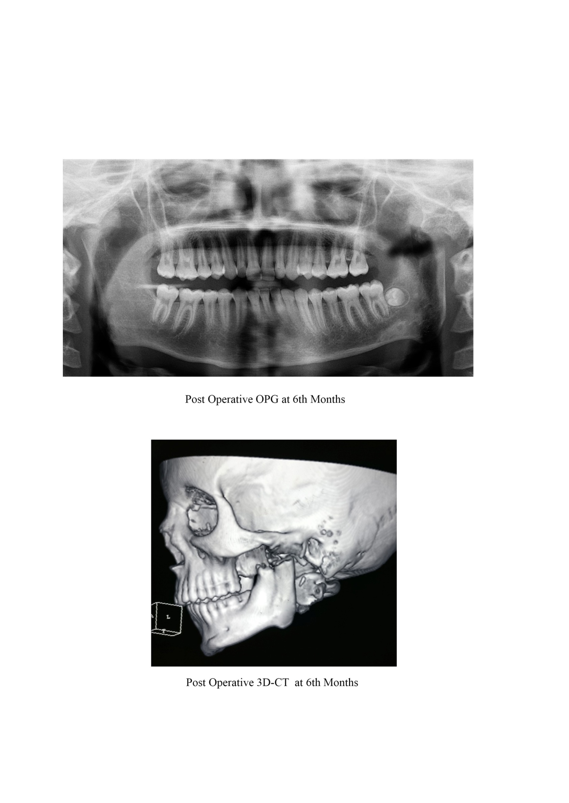
Fig No. 3.66 Post-Operative OPG at 6th Month

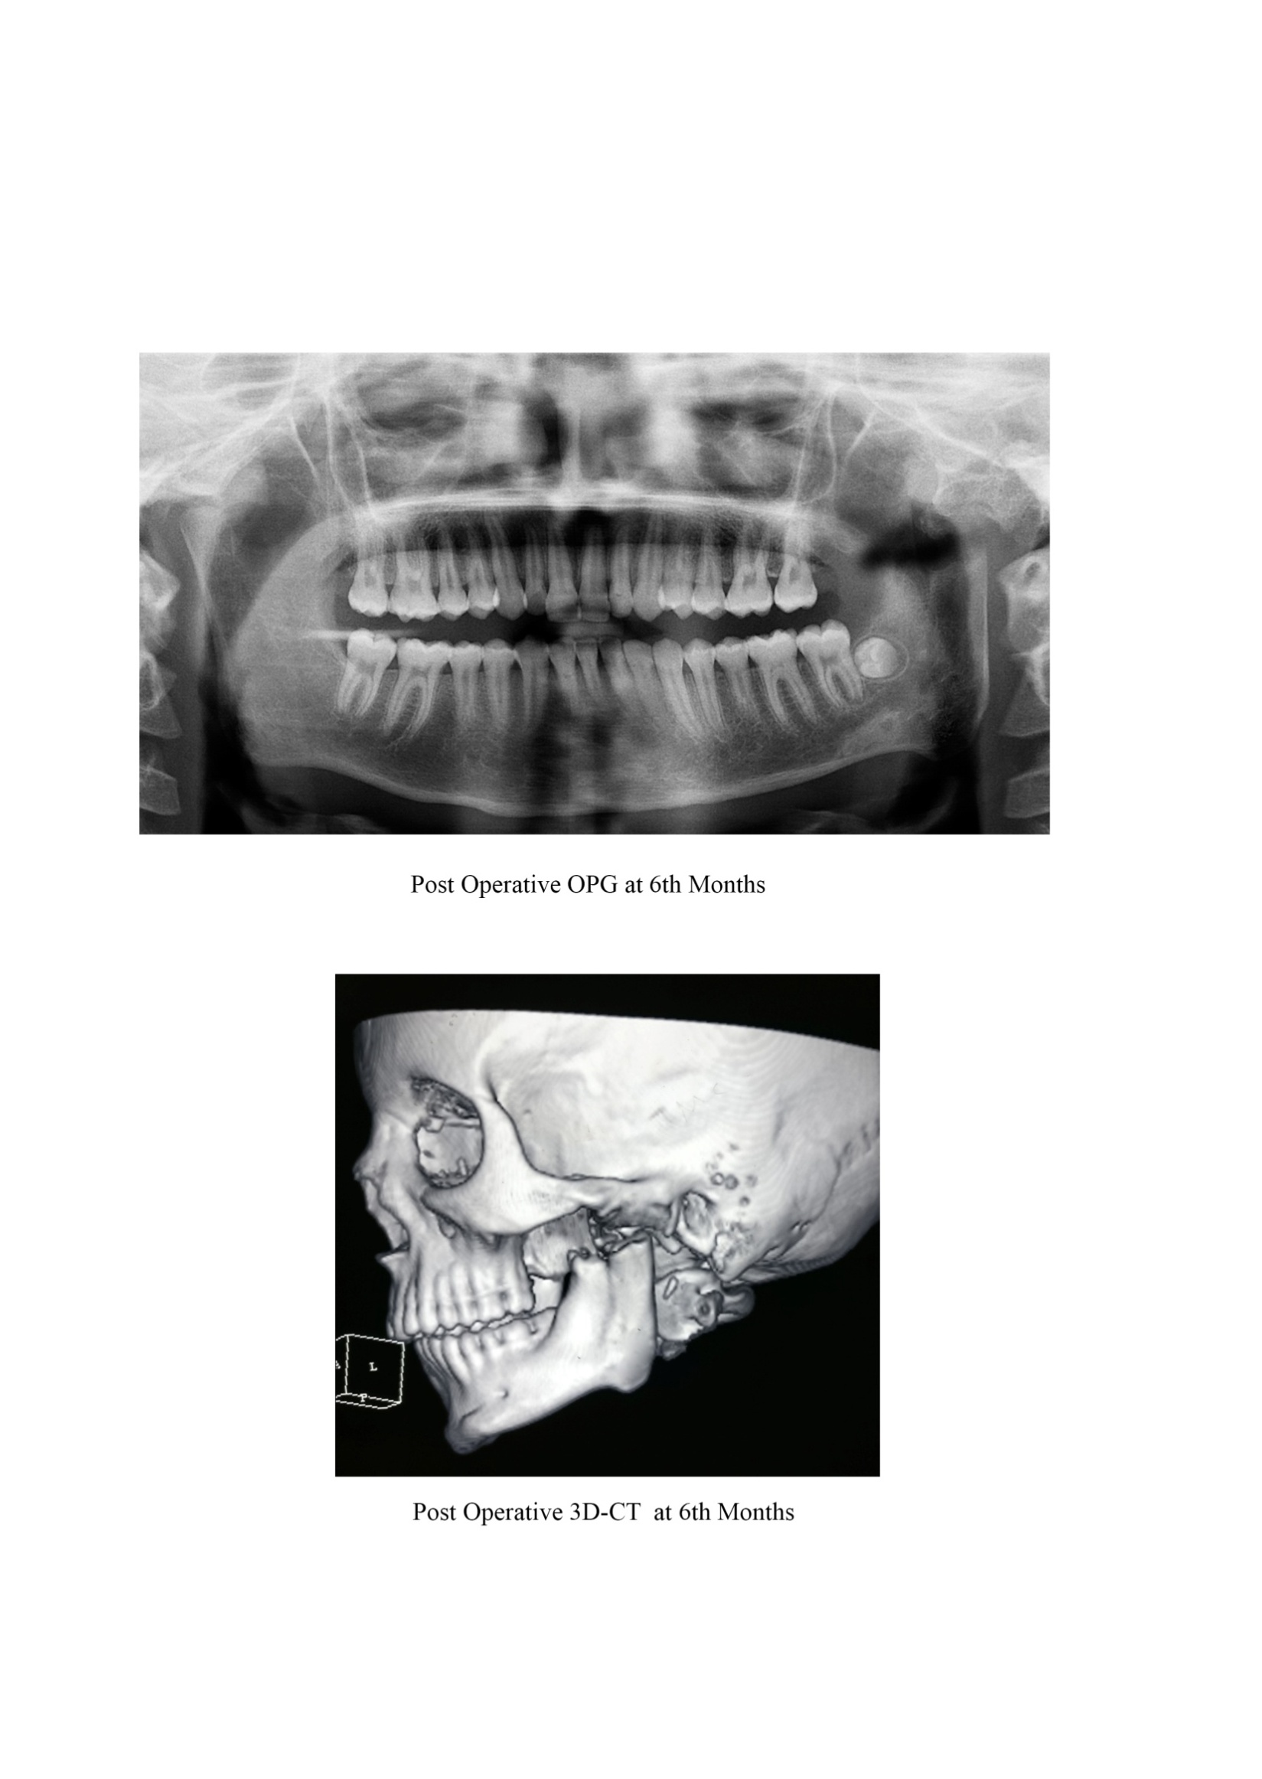
Fig No. 3.67 Post Operative 3D-CT at 6th Month

